Role of rifampicin in reducing poor fetal and neonatal outcome in intrahepatic cholestasis of pregnancy
Manoj Kumar
All India Institute of Medical Sciences, India
Abstract
Statement of the problem: Preterm birth which affects 11% of all births worldwide, leads to approximately 20% neonatal mortality. Both iatrogenic and spontaneous preterm births are known complications of Intrahepatic Cholestasis of Pregnancy (ICP). Elevated maternal serum bile acids are implicated as causing poor fetal outcomes in ICP. Various pharmacological agents are used to lower it, but none is based on high level of evidence. Ursodeoxycholic acid (UDCA) is used most widely, but some patients do not respond to it. Rifampicin has recently been identified as an adjunct drug in ICP but fetal and neonatal outcomes need to be documented for the same.
Methodology: 108 pregnant women with ICP who were receiving UDCA with or without rifampicin were enrolled in this prospective observational study at a tertiary hospital from December 2018 to November 2020. Seventy-eight patients who received only UDCA were labelled as group A and 30 patients receiving UDCA with rifampicin were labelled as group B [Figure 1].
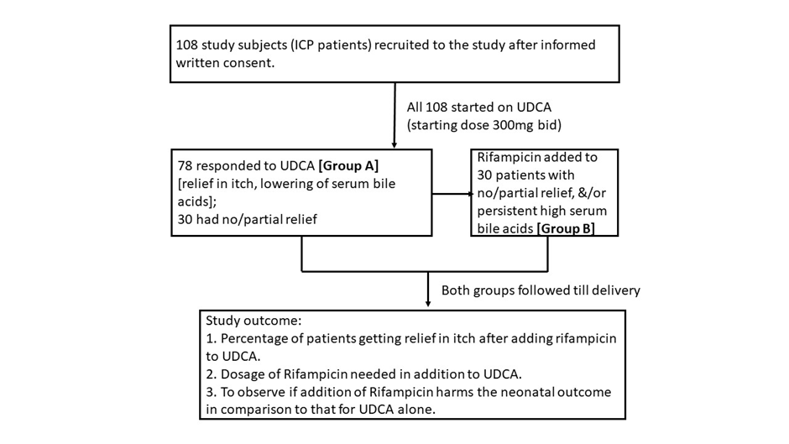
Figure 1. Flowchart showing study methodology in brief.
Results: Group B patients had earlier onset of symptoms and earlier mean {Standard Deviation (SD)} gestational age at diagnosis at 28.89 (4.29) weeks compared to 32.47 (2.93) weeks in group A. Therefore, mean (SD) gestational age to start UDCA was early in group B (29.32 (4.24) weeks). Mean (SD) gestational age to start rifampicin was 32.11 (3.4) weeks for group B (n=30). Mean (SD) dosage of UDCA was 911.54 (229.05) mg/day and 880 (260.50) mg/day in groups A and B (p value=0.563). Mean (SD) dosage of rifampicin used in group B was 700 (363.89) mg/day. Mean (SD) baseline bile acids (pre-treatment) was 36.94 (13) micromol/L and 42.50 (15.23) micromol/L in groups A and B, respectively (p value=0.274). At two-week follow-up, mean (SD) value of serum bile acids was 22.92 (10.67) micromol/L and 14.88 (10.27) micromol/L in groups A and B, respectively (p value=0.039). Group B having an earlier onset of ICP also had early gestational age at delivery at 35.70 (2.57) weeks versus 37.011 (1.18) weeks in group A. 63% and 50% babies were born full term in groups A & B respectively (p value 0.222). Mean (SD) birth weight of babies was 2,706.85 (206.19) grams for group A and 2,522.67 (342.20) grams in group B (p value=0.009). Rate of antepartum stillbirth in groups A and B was 9% and 6.7% respectively (p value=0.722). 10.3% and 6.7% babies were born with dark-coloured meconium or placental membranes and cord stained with meconium in groups A & B respectively. In groups A and B, 9% and 6.7% of the babies were born with thin/light green meconium-stained liquor, respectively. So, overall adverse neonatal outcomes for both groups were comparable (68.5% in group A and 70% in group B) (p value=0.881).
Conclusion: Rifampicin is a useful adjunct to UDCA lowering serum bile acids in pregnant women with early onset, severe and resistant cases of ICP. Fetal outcomes are not worsened and in fact there is a benefit of delaying birth-timing by adding rifampicin to UDCA thereby improving overall fetal outcomes in such cases of ICP.
Biography
Manoj Kumar studied MBBS from Patna Medical College and Hospital, Patna and did his postgraduation for MD (Pediatrics) in DMCH, Darbhanga. He has more than 8 years of teaching experience in undergraduate & postgraduate medical education and research. At present he is working as Assistant Professor in the Department of Pediatrics, at All India Institute of Medical Sciences, Deoghar, India. His areas of expertise are Neonatology & Pediatric Nephrology. He has 18 publications in national and international journals to his credit. He is a lifetime member of IAP (Indian Academy of Pediatrics) & National Neonataology Forum of India. He is a reviewer in PubMed journal and also chaptered a book on recent advances in medical sciences and research.

