Effect of laser surface remelting on the microstructure, mechanical, tribological and corrosion properties of the Ti40Nb25Zr25Ta10 (with 0.5 at.% O) Medium Entropy Alloy (MEA)
L Mustafi¹*, A Jones¹, VT Nguyen², Q Deng¹, X Chen¹, T Song¹, DM Fabijanic³ and M Qian¹
¹RMIT University, Australia
²University of Queensland, Australia
³Deakin University, Australia
Abstract
High-Entropy Alloys (HEAs)/Medium-Entropy Alloys (MEAs) provide a novel design concept for metallic biomaterials. A non-equiatomic bio-applicable as-cast Ti40Nb25Zr25Ta10 (with 0.5 at.% O) MEA was surface remelted by laser. The consequent effect on the constituent phases, microstructures, mechanical properties, tribological and corrosion resistance properties was investigated. The alloy exhibited a stable body-centred cubic phase after laser surface remelting with a significant decrease in grain size from about 106 μm to 12 μm, accompanied by an increase in hardness from 4.44 ± 0.29 GPa to 7.58 ± 0.15 GPa. Accordingly, the wear rate decreased by 22.5% at applied loads in the range of 200-600 μN loads. The corrosion current density of the laser surface remelted MEA (0.013 ± 0.06 μA/cm²) was reduced compared to the as-cast microstructure (0.034 ± 0.08 μA/cm²) in Hank’s solution. The improved corrosion resistance can be attributed to the resulting finer grain sizes. Laser surface remelting offers a potential approach for modifying the Ti40Nb25Zr25Ta10 MEA for biomedical applications [Figure 1].
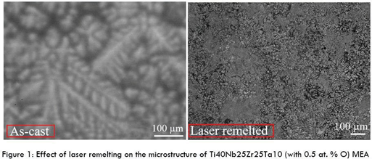
Figure 1. Effect of laser remelting on the microstructure of Ti40Nb25Zr25Ta10 (with 0.5 at.% O) MEA.
Biography
Labani Mustafi is a Higher Degree Research Candidate at Centre for Additive Manufacturing, School of Engineering, RMIT University, Melbourne, Australia. She completed her M. Eng. degree in materials science from Harbin Institute of Technology, China and B.Sc. (Hons) degree in Materials Science and Engineering, Rajshahi University, Bangladesh. Her research focuses on the design and development of strong and ductile high entropy alloys and medium entropy alloys for biomedical applications. Her research also spans on the development of titanium alloys for high temperature applications, 2D and Diamond Like Carbon (DLC) materials for tribological applications. She has an expertise on materials design and fabrication via conventional casting, additive manufacturing, Chemical Vapour Deposition (CVD), thermo mechanical heat treatment methods, simulating phase diagram using different software, characterizing samples using advanced microscopy techniques, mechanical and tribological performances testing and electrochemical corrosion testing. Her research outputs have been published/presented in prestigious scientific journals and international/national conferences.

