Dual ceramic composed by organic-inorganic functional polymer gel electrolyte for dendritic-free and robust lithium metal batteries
Sajid Hussain Siyal^{1,2}*, Muhammad Sufyan Javed³ and Yunhua Yu²
¹Dawood University of Engineering and Technology, Pakistan
²Beijing University of Chemical Technology, People's Republic of China
³Jinan University, People's Republic of China
Abstract
Lithium-Metal Batteries (LiMBs) are promising energy storage devices due to the high capacity and minimum negative electrochemical potential. Nevertheless, their concrete applications remain disturbed by unbalanced electrolyte-electrode interfaces, limited electrochemical window and high-risk. Herein, a novel strategy to obtain dual ceramic-based electrolytes that possesses great potential in energy storage due to their higher level of energy densities in LiMBs. Dual-Ceramic (LATP-LLTO) Gel Polymer Electrolyte (DCGPE) [Figure 1] film developed via the curable system, aimed to prepare flexible Li⁺ interpenetrating network film to integrate the two ceramic structures with Poly Ethylene Oxide (PEO) to yield the free-standing electrolytes film for better battery safety and desired interfacial stability. The DCGPEs films presented a satisfactory electrochemical performance, including, good ionic conductivity, large transference number and wide Electrochemical Stability Window (ESW) at room temperature. Most importantly, the fundamental function of LATP and LLTO is to support building a stable Solid-Electrolyte-Interphase (SEI) and limits the growth of dendrites. Thus, prepared dual ceramic-based electrolytes effectively renders to inhibit lithium dendrite growth in a symmetrical cell Li//PEO+10% LATP+15% LLTO//Li test during charge/discharge at a current density of 2 mA/cm² and 0.25 mA/cm² above 2400 h without short-circuiting occurrence at room temperature. Besides, the battery assembled of LiFePO₄/PEO+10% LATP+20% LLTO/Li exhibits superior cyclic stability with high Coulombic efficiency. This study recommends that the binary network structures of Li-ion conductor help to design a prime solution of promising electrolyte for high- performance LiMBs applications.
Keywords: Dual ceramic gel polymer electrolytes, LATP, LLTO, PEO, PVP, Lithium-metal batteries, Li-dendrites.
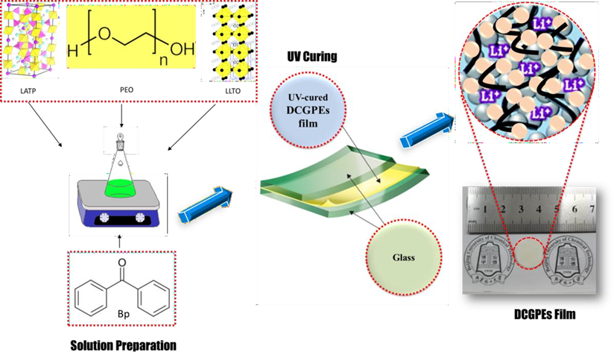
Figure 1. Design of ceramic-ceramic dual composite gel polymer electrolytes film (DCGPE).
Biography
Sajid Hussain Siyal is currently working as Associate Professor/Chairman Department of Metallurgy and Material Engineering, Dawood University of Engineering and Technology Karachi. He joined DUET in 2009 as Lecturer. His research is in the synthesis of Nano composites of battery materials, Nanotechnology, Polymeric/Ceramic Materials. He completed his doctorate from Advanced Composite Center, State Key Laboratory of Organic-Inorganic composites, Beijing University of Chemical Technology.

