Distinct molecular formation in laser-induced carbon plasmas in air
H Yousfi¹*, S Abdelli-Messaci² and O Ouamerali²
¹Laboratory of Theoretical Computational Chemistry and Photonics (LCTCP), Algeria
²Center for Development of Advanced Technologies, Algeria
Abstract
In this work, we are investigating the time- and space- resolved characterization of carbon plasma produced by infrared nanosecond laser ablation into the air at atmospheric pressure. The emission intensities of different atomic, ionic, and molecular species were observed as functions of time and distance with respect to the target surface, while the applied laser fluence is varied to study its influence on the plasma composition. The electron density and plasma temperature are estimated along the expansion axis. The vibrational temperatures of CN and C₂ molecules are determined using the Nelder Mead Temperature program. These temperatures were found distinct indicating a significant shock wave may form to affect the occurrence of C₂ and CN formation. It was found that at a given distance from the target surface and for a time delay of 2 µs, the plasma temperatures and the vibrational ones is similar. The carbon plasma chemistry is studied using a kinetic model to understand the temporal distribution of molecules near equilibrium at similar conditions to those measured experimentally [Figure 1].
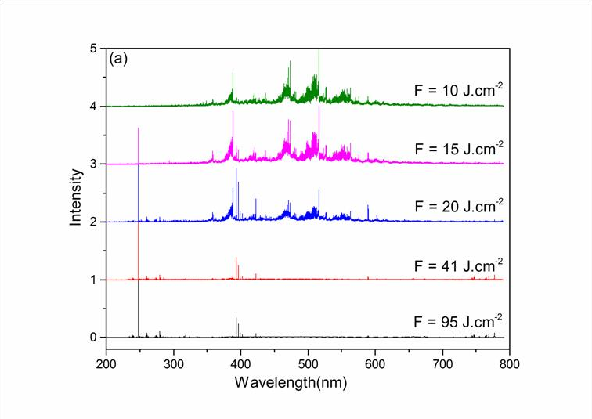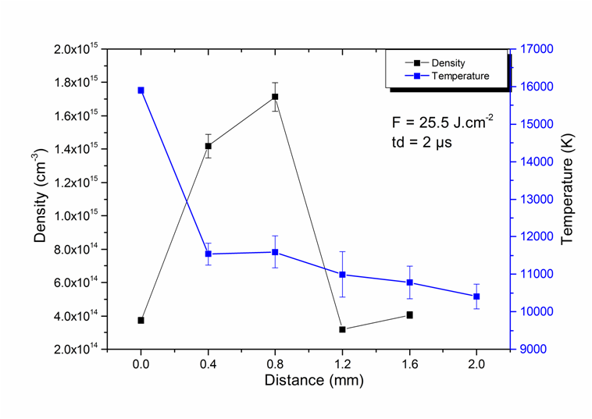
Figure 1. (a) Emission spectra of carbon plasma into air at different fluences at atmospheric pressure. (b) Plasma electron density and temperature versus distance from the target surface at a time delay of 2 µs.
Keywords: Laser-induced carbon plasma, Laser ablation, Kinetic model.
Biography

