Feasibility of a symptoms management intervention for Honduran adults undergoing chemotherapy
Rennie Michelle Medina¹* and Kathleen Doyle Lyons²
¹Universidad Catolica de Honduras, Honduras
²Dartmouth Hitchcock Medical Center, USA
Abstract
Evidence-based interventions often need to be adapted to maximize their implementation potential in low-to middle- income countries. A single-arm feasibility study was conducted to determine the feasibility and acceptability of a telephone-delivered, nurse-led, symptom management intervention for adults undergoing chemotherapy in Honduras. Over the course of 6 months, nurses engaged 25 patients undergoing chemotherapy in the intervention [Table 1]. Each participant received an average of 16.2 attempts to contact them for telephone sessions (SD=8.0, range=2-28). Collectively, the participants discussed 24 types of symptoms. The most commonly discussed symptoms were pain (12%), nausea (7%), and constipation (5%). Qualitative and quantitative data were used to identify treatment manual modifications (i.e., adding content about symptoms and addressing scheduling of treatment) and workplace modifications (i.e., dedicated nurse time and space) that are needed to optimize implementation of the intervention.
Table 1. Participant characteristics (N=25)
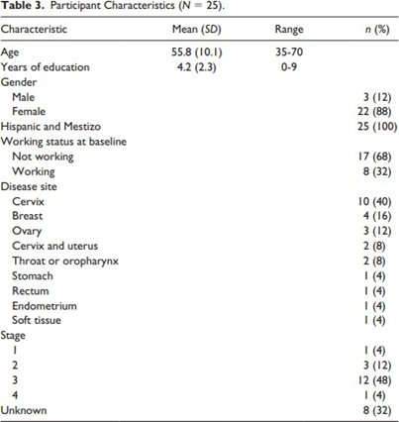
Biography
Rennie Medina is originally from San Pedro Sula, Honduras where she attended Universidad Catolica de Honduras for her undergraduate degree in Medicine. While attending college she trained and volunteered in PESCA, group of medical staff dedicated on promoting cervical cancer screening with cytology for free in Honduras. In 2018 she had the opportunity to meet Sylvia Bahr, who implemented workshops on respectful maternity care and human rights childbirth with nurses in Honduras. In her spare time she enjoys traveling, learning new languages, and spending time outdoors, and is also involved in medical missions donating her time in clinics or hospitals.

