Enhancing the neuroprotection potential of edaravone in transient global ischemia treatment with glutathione (GSH) conjugated poly (methacrylic acid) nanogel as a promising carrier for brain drug delivery
Soroush Bijani* and Mir-Jamal Hosseini
Zanjan University of Medical Sciences, Iran
Abstract
Statement of the problem: Ischemic stroke is the most common among various stroke types and the second leading cause of death worldwide. It suggested that oxidative stress is the main mechanisms associated with ischemic stroke pathophysiology. Edaravone (EDV) is one of the cardinal antioxidants that is capable of scavenging oxygen species free radicals specially hydroxyl molecule. Low water solubility, stability and bioavailability in aqueous medium are major EDV drawbacks. Decorating nanogel surface with glutathione to target brain tissue was performed to optimize drug delivery.
Methodology & theoretical orientation: Nano vehicle characterization was assessed with FT-IR and HNMR. Images from the surface of nano vehicle were captured by AFM and TEM instruments [Figure 1]. After development of mPEG-b-PLGA EDV nano particles their effect on biochemical factors including malondialdehyde, protein carbonyl level was measured on Wistar rats under global ischemia. In addition, the amount of reduced Glutathione and total cellular antioxidant were also measured.
Findings: The Size (199 nm, hydrodynamic diameter) and zeta potential (-25 mV) of optimum formulation was assessed and the calibration curve in deionized water was created at 244 nm. Encapsulation Efficiency and drug loading were determined to be 37.45 % and 99.88% respectively. In vitro drug release profile depicted a sustained release process. EDV and glutathione presence in one vehicle simultaneously, made the possibility of antioxidant and anti-apoptotic application to the brain in specific doses which resulted in elevated spatial memory and learning along with cognitive functions in Wistar rats. In addition, significantly lower MDA and PCO as the byproducts of ROS and higher level of neural GSH and total antioxidant level were observed.
Conclusion: The developed mPEG-b-PLGA EDV nanogel can be a suited vehicle for brain drug delivery of EDV to the brain, while managing to minimize the biochemical and pathophysiological alterations in ischemic-like disorder.
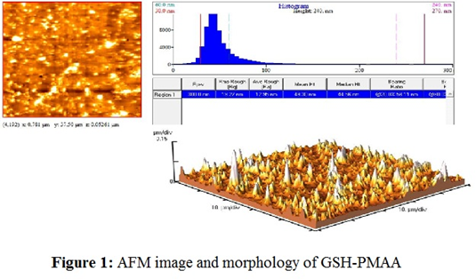
Figure 1. AFM image and morphology of GSH-PMAA.
Biography
Soroush Bijani has completed his Pharm.D at the age of 24 years from Zanjan University of Medical Sciences. Aside of serving as a community pharmacist, he is a teacher assistant and a member of Zanjan Applied Pharmacology Research Center. He has published more than 12 papers in reputed journals and has been serving as a reviewer of journals in the field of neurosciences.

