Investigation of magnetotocosome as the magnetic targeting drug delivery system for Sorafenib tosylate anticancer drug
Gholamhossein Sodeifian
University of Kashan, Iran
Abstract
Hepato-Cellular Carcinoma (HCC) is the fifth prevalent malignant tumor having the third rank in the global mortality chart. Sorafenib tosylate (SFB) is approved as the first anticancer drug for the treatment of HCC. According to the Biopharmaceutical Classification Scheme (BCS), SFB belongs to class II compounds that indicate a very poor solubility in the aqueous solution at different pH values from pH=1.2 to pH=7.4 (slow dissolution rate within the gastrointestinal tracts) and high permeability from the gastrointestinal lumen. The drug has low oral bioavailability (8.43%); consequently, high dose treatment is necessary which may cause the systemic toxicity [Figure 1]. Nanotechnology based novel drug delivery systems are applied to design the systems with improved biocompatibility and biodegradability which can deliver the drug molecule efficiently and safely to the target tissue thus decrease the side effects, especially for drugs with narrow therapeutic index or cytotoxic effects. In this research, for the first time, the magnetotocosome was developed as the biocompatible nanocarrier with improved drug encapsulation efficiency (up to 77%), extended stability, proper particle size (<150 nm) and industrial upscaling (Mozafari method was applied to prepare the tocosome) for controlled drug delivery of sorafenib tosylate to cancerous tissue. The optimum composition of tocosome was determined based on particle size and drug loading and then it was used to prepare the magnetotocosome [Figure 2]. In addition, the effect of phosphatidylcholine on the properties of Super Paramagnetic Iron Oxide (SPIO) nanoparticles was examined. The prepared nanocarrier can improve bioavailability of drug and be used in the hyperthermia and controlled and targeted release of drug particles.
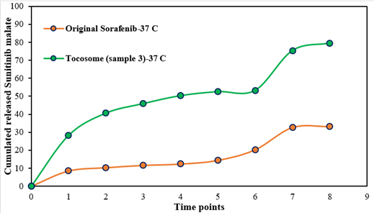
Figure 1. Cumulated release profiles of SFB from designed drug delivery system at different times.
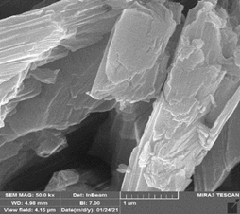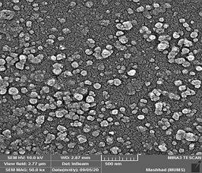
Figure 2. FE-SEM images of original SFB and Magnetotocosome suspension.
Biography
Gholamhossein Sodeifian (1971) graduated in chemical engineering (M.S) from University of Tehran, in 1997 and received his doctorate (PhD), in polymer engineering from Tarbiat Modares University, Tehran, in 2002. He is currently academic member of Chemical Engineering Department of University of Kashan. His research group focused on extraction of essential and seed oils, solubility measurement of solid medicines and micro and nanoparticle formation of pharmaceutical materials in Supercritical Carbon Dioxide (SCCO₂) via various methods. He has also developed, for the first time in the world; a new and efficient technique for nanoparticle formation, i.e., Ultrasonic assisted Rapid Expansion of Supercritical Solution into a Liquid Solvent (US-RESOLV). He has published more than 83 ISI scientific papers and several books. Furthermore, he has developed Sodeifian’s model for drugs solubility. He has been assigned and included in the worlds’ top 2% of scientists list in 2021 and 2022.

