Reticulated platelets: A key to platelet heterogeneity
Nikita Ilkevich
University of Westminster, United Kingdom
Abstract
Primary function of platelets is the formation of a protective barrier against blood loss. Secondary but no less important functions of platelets are tissue repair and immunity. Similar to the functioning of much of the rest of biology the exchange of phosphate groups plays a key role in the functioning of platelets. This exchange is potentiated by phosphatase and kinase enzymes. The CD148 encoded by PTPRJ is a phosphatase that is implicated both positive and negative regulation of platelet activation. Despite recent advances in understanding of CD148 the exact level of expression, structure, mechanism of action and precise role in the functioning of platelets are still not one hundred percent clear. The level of expression was the focus of the study. Finding the optimal method of visualising CD148 expression was the initial aim of the study. In the process of investigation, the varying levels of CD148 expression have pointed the researchers to the possibility that different subpopulations of platelets express CD148 at a varying level. Reticulated platelets (younger subset of the platelet population) were picked as most promising subpopulation. Syto 13 a nucleic dye was used distinguish reticulated platelets rather than a more traditional thiazole orange. The study proved successful in confirming the differences in the level of expression of CD148. Reticulated platelets were shown statistically and graphically to express more CD148 than the rest of the population (Figure 1). Suggestions for further research and modalities of possible therapies were made.
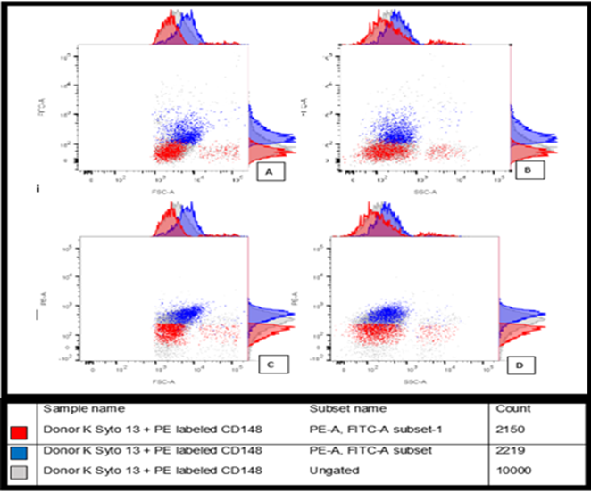
Figure 1. Graphical conformation of Hypothesis. Here the two subsets and overlayed on top of general population and arranged according to their FSC-a and SSC-A on the X-axis with the signal strength of syto 13 and PE labels on Y-axis of the panels A and B for syto 13 and C and D for PE signal of the anti-CD148. The adjunct histogram’s represent frequency of cells in either.
Biography
Nikita has expertise in flow cytometry. Combined with evolutionary biology new insight has been made into the expression of CD148 and into the way in which it relates to platelet subpopulations. The work was mainly based on the Mori et al 2018.

