Investigation of the oncolytic effects of Myxoma virus in multiple myeloma cells
Yesilaltay A¹*, Muz D², Erdal B², Bilgen T², Batar B², Altındağ Avcı B² and Turgut B²
¹Baskent University, Turkey
²Namik Kemal University, Turkey
Abstract
Introduction: Multiple Myeloma (MM) is a malignant disease of plasma cells. Oncolytic viruses do not infect healthy cells, cause selective death of cancer cells. MYXV is more effective in its oncolytic capacity and seems to have minimal adverse effects. It has been proven in vitro that MYXV cause apoptozis in malign plasma cells. It was aimed to investigate both the oncolytic effect of MYXV and its effect with drug combinations in patient-derived MM cells.
Methodology: In the study, two commercially different MM cell lines and cultures prepared from a total of 30 patients with newly diagnosed MM (n=15) and relapsed refractory MM (n=15) specimens will be prepared from bone marrow samples of patients. Patient-derived primary MM cell and MOPC-315, U266 cell lines were used. In infecting MM cells with MYXV at different doses, and in differing combinations of PZI/IMID drugs; cell viability was assessed using WST-1 test and apoptosis analysis was assessed using flow cytometry techniques.
Finding: It was observed that MYXV infects cells with different titers (5,10,20 and 50 moi) both in patient and continuous cell lines. The increase in virus quantity was linearly correlated with the number of cells infected and with the degree of cytotoxicity. In trials of the virus with drug combinations, apoptosis was detected in flow cytometry with Annexin-V. It was noted that apoptotic cell rates were highest with the triple drug combination.
Conclusion: The oncolytic effect of MYXV was demonstrated in MM cell cultures of patients. Cellular cytotoxicity varied based on the amount of the virus. In trials with drug combinations used in the routine treatment of MM, it was noted that addition of the virus increased apoptotic changes. This finding suggests that the use of this particular oncolytic virus in routine treatment protocols, especially in these patients, may reduce the amount of medication.
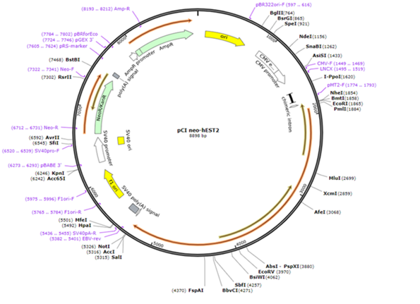
Figure 1. Schematic map of the vector to be used in the hTERT immobilization protocol.
Biography
Alpay Yesilaltay is an Internal Diseases and Hematology specialist and PhD in Cancer Immunology. He received his Internal Medicine and Hematology specializations after MD certificate from Istanbul University Cerrahpaşa Faculty of Medicine. He worked at Arkansas Medical School Myeloma Institute between 2016-2017. He is responsible for the project on the Effects of Oncolytic Viruses on Myeloma, supported by TÜBİTAK within the framework of alternative treatment studies in Multiple Myeloma. Autophagic effects of Oncolytic viruses in Myeloma continue to be studied. Myeloma Cancer Stem cell, Membrane potentials in cancer cells, oncolytic viruses, Endoplasmic reticulum stress and Autophagy are of special interest.

