Comparable b2a2/e13a2 and b3a2/e14a2 reporting in Xpert® BCR-ABL ultra when calibrated by WHO IS and by IVT-RNA copy number
Huilin Wei*, Tran Tran, Jessica Saini, Krupa Shridhar, Nick Wang and Gwo-Jen Day
Cepheid, USA
Abstract
Introduction: Xpert® BCR-ABL Ultra, automated cartridge-based assay for monitoring BCR-ABL transcript levels, is calibrated by WHO IS to standardize the % reporting for both b2a2/e13a2 BCR-ABL (e13a2) and b3a2/e14a2 BCR-ABL (e14a2) relative to control ABL gene in peripheral blood of patients as a standard management of Chronic Myeloid Leukemia (CML). Studies have shown differences in patients carrying e13a2 or e14a2 in molecular response to Tyrosine Kinase Inhibitor (TKI) treatment. Therefore, it is necessary to understand if there is % reporting differences between two transcripts calibrated by WHO IS and explore the calibration method using breakpoint specific RNA input Copy Number (CN) for accurate TKI treatment monitoring.
Objectives: To establish a % CN e13a2/ABL and e14a2/ABL reporting method with known CN of IVT-RNAs and compare to WHO IS for e13a2/e14a2 breakpoint specific % reporting.
Methods: Three IVT-RNAs (e13a2-ABL-BCR, e14a2-ABL-BCR and ABL-BCR) were used to generate standard curves for % CN reporting (Figure 1). Four levels of IVT-RNA panels with same CN of e13a2 and e14a2 were tested for breakpoint specific % reporting comparison. K562 (e14a2), BV173 (e13a2) cell lysates and CML clinical samples carrying e13a2 or e14a2 transcripts were tested to evaluate the % CN reporting compared to WHO IS.
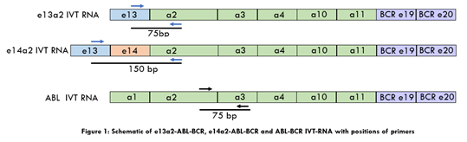
Figure 1. Schematic of e13a2-ABL-BCR, 1402-ABL-BCR and ABL-BCR IVT-RNA with positions of primers.
Result: Good linearity demonstrated in Ct vs. CN input for e13a2, e14a2 and ABL IVT-RNA (Figure 2) with comparable Efficiency (E) between e13a2 (E=0.992) and e14a2 (E=0.986). % e13a2 reporting was ~1.50-fold (by WHO IS) and ~1.46-fold (by % CN) higher than % e14a2, by testing IVT-RNA panel (Table 1). Minor differences in % reporting observed between % CN and WHO IS for e13a2 (84.5%~110.8%) vs. e14a2 (82.5%~89.5%) from cell lysates (Table 2) and e13a2 (92.6%~105.5%) vs. e14a2 (88.1%~92.2%) from clinical samples (Table 3).
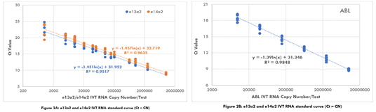
Figure 2. 102 and 1402 IVT RNA standard curve (CCN), 132 and 1402 VT RNA ondare (CN).
Table 1. e13a2 and e14a2 IVT RNA panel test.
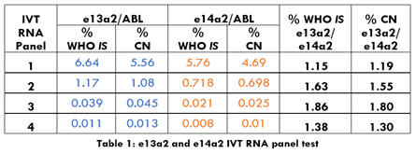
Table 2. % CN and % WHO IS from unknown % e13a2 and % e14a2 cell lysates.
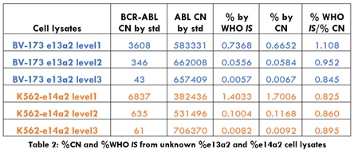
Table 3. % WHO IS and % CN from e13a2 and e14a2 CML clinical samples.
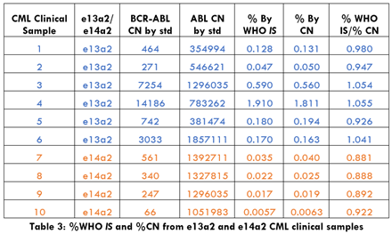
Conclusion: Both WHO IS and % CN showed very minor differences between e13a2 and e14a2 for % reporting. % CN method demonstrated comparable % reporting to WHO IS.
Biography
Huilin Wei has more than 15 years of extensive experience in molecular and protein assay development. She has her expertise in molecular biology, immunology and oncology. Current research focuses on assay control and detection platforms to provide accurate and high quality IVT products for cancer diagnostic and monitoring.

