An unusual case of chronic myelogenous leukemia and multiple myeloma co-existence
Victor Alfred H. Cataming* and Teresita E. Dumagay
University of the Philippines, Philippines
Abstract
The co-existence of myeloid and lymphoid malignancies is rare and poorly understood. It is an extremely uncommon disease reported in a very few cases. We report a rare case of multiple myeloma and chronic myelogenous leukemia co-existence in a 55-year-old male initially presenting with granulocytosis and splenomegaly. Subsequent work-up with BCR/ABL FISH assay and bone marrow aspiration and biopsy revealed chronic myelogenous leukemia. During the first 4 months of his treatment with a tyrosine kinase inhibitor, there was a note of progressive and persistent pancytopenia with increasing creatinine trends. A repeat bone marrow aspiration and biopsy supplemented with serum protein electrophoresis with immunotyping and serum free light chain assay were done demonstrating multiple myeloma. A BCR-ABL for QRT PCR was also conducted with a result of 3.81%. Hence, the diagnosis of co-existent multiple myeloma and chronic myelogenous leukemia, Triplet anti-myeloma therapy and tyrosine kinase inhibitor are given to this patient.
Multiple myeloma is the neoplastic expansion of plasma cells that produces a monoclonal immunoglobulin. It is a relatively uncommon malignancy. On the other hand, chronic myelogenous leukemia is a form of myeloproliferative neoplasm that results from abnormal production and proliferation of mature and maturing granulocytes associated with the BCR/ABL fusion gene. The abnormal cells involved in these diseases are distinctly different making its co-occurrence extremely rare. In addition, literature regarding the approach to its diagnosis, treatment and outcome is scarce. Increasing recognition and awareness of the co-existence of the two entities is a step closer to optimizing approach to its diagnosis and treatment [Figure 1].
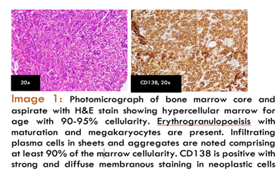
Figure 1. Photomicrograph of bone marroe core and aspirate with H&E stain showing hypercellular marrow for age with 90-95% cellularity. Erythrogranulopoeisis with maturation and megakaryocytes are present. Infiltrating plasma cells in sheets and aggregates are noted comprising atleast 90% of the marrow cellularity. CD138 is positive with strong and diffuse membranous staining in neoplastic cells.
Biography
Victor Alfred H. Catambing is a board-certified internist and is currently an adult hematology fellow-in-training from the Philippine General Hospital, Philippines. He is an enthusiastic and innovative fellow-in-training whose life-long goal is provide the best possible care to patients with hematologic conditions in distant areas of the Philippines.

