Primary Extradural Lymphoma with marginal zone transformation : A Rare Presentation
Dr. Shuchita Pathak, Medical oncology, MS Ramaiah Medical college
Dr Santhosh KD, Consultant Medical Oncologist, MS Ramaiah medical college

ABSTRACT : A 38 year old female presented in our institute with 2 months history of paraparesis with loss of sensation below umbilicus. Diagnostic workup revealed extradural mass at thoracic vertebral level 4 to 6. She underwent D3-D6 laminoplasty with excision of lesion. Histopathology report revealed Non Hodgkin lymphoma for follicular centre cell type with marginal zone transformation. On further evaluation PET-CT scan was done which confirmed localised primary extradural location of non hodgkin lymphoma. She received modified R-GMALL protocol chemotherapy. Her neurological condition improved at end of chemotherapy.

Image
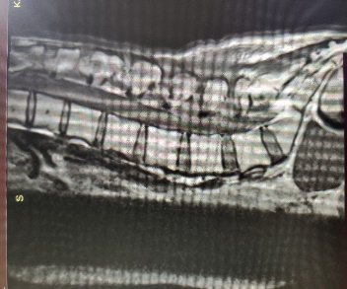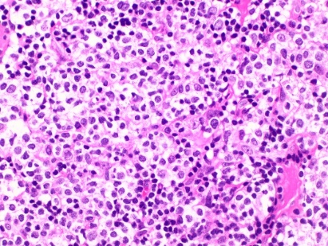

Figure 1&2: R-GMALL protocol chemotherapy
Recent Publications (minimum 5)
- Alderuccio JP, Zhao W, Desai A, et al. Risk factors for transformation to higher-grade lymphoma and its impact on survival in a large cohort of patients with marginal zone lymphoma from a single institution. J Clin Oncol 2018.
- Juan Pablo Alderuccio , Izidore S. Lossos et al. Prognostic factors and risk of transformation in marginal zone lymphoma. Annals of Lymphoma. 2020.
- Mark Bustoros, Benjamin Liechty et al.A Rare Case of Composite Dural Extranodal Marginal Zone Lymphoma and Chronic Lymphocytic Leukemia/Small Lymphocytic Lymphoma,2018. Front. Neurol.,2018
- Rakesh Kapoor, vinay kumar et al. Primary extradural non Hodgkin lymphoma, 2006.JK Science;vol8 No1,Jan-March 2006
- Yahalom J, Illidge T, Specht L, Hoppe RT, Li YX, Tsang R, et al. Modern radiation therapy for extranodal lymphomas: field and dose guidelines from the International Lymphoma Radiation Oncology Group. Int J Radiat Oncol Biol Phys. 2015;92(1):11–31.



Dr Shuchita Pathak working as DM medical oncology resident in M S Ramaiah medical college banglore .I completed my MBBS in 2014 from GMC haldwani medical college in uttrakhand.After that completed my DNB radiation oncology post graduation from Bhagwan Mahaveer cancer hospital,Jaipur.After completing my post graduation I worked as senior resident in AIIMS New delhi for 1 year and after that got selected for medical oncology in M S Ramaiah medical college.
Shuchi1104@gmail.com

Notes/Comments:

Presenting author details
Full name: Shuchita Pathak
Contact number:9680119691
Twitter account:shuchi1104
Linked In account:shuchi1104
Session name/ number: 300#
Category: (Oral presentation/ Poster presentation):- Poster Presentation

