

PhD Candidate at ERASMUS+ Mobility Students Programme

Erasmus+ Programme–KA107 project n. 2020-1-IT02-KA107-078816, coordinated by the Università degli Studi della Tuscia (Italia) and funded by the European Commission,

Ph.D. Proposal Project

(Dec. 19th, 2022)
Principle Investigator: Ghazwan Ahmed M. Raouf- Ph.D. Student in Toxicology, Prof. ( ).

Project Title:

Toxic impacts of SARS-CoV-2 variants and anti-viral potential effects in hospitalized patients in Duhok Province-Kurdistan Region
The coronavirus disease 2019 (COVID-19) pandemic was caused by a novel coronavirus the well-known severe acute respiratory syndrome coronavirus 2 (SARS-CoV-2) that emerged in 2019, the crisis that didn’t respond to standards of care over the world including well-developed countries. Clinicians need to be mindful of the toxicity of a wide variety of possibly unfamiliar substances being tested or repurposed to treat COVID-
19 including poly-pharmacy. Flu-like symptoms, were the most accompaniment of novel coronavirus infection, progressing in some cases to acute respiratory distress syndrome (ARDS) that eventually leads to death. Toxic impacts of coronavirus increase the probability of developing life-threatening systemic inflammatory syndromes called cytokine storms that suddenly deteriorate a patient's status to a severe or critical condition and might evoke oxidative stress, raising mortality rates. Oxidative stress can be measured indirectly by measuring DNA/RNA damage levels, lipid peroxidation, and protein oxidation/nitration, rather than a direct measurement of reactive oxygen species. It has been confirmed that oxidative stress is involved in a variety of diseases, such as pneumonia, pancreatitis, diabetic nephropathy, cardiovascular disease, nervous system disease, and cancer. Therefore, the total oxidant status (TOS) is usually used to estimate the overall oxidation state of the body. Similarly, total antioxidant capacity (TAC) is used to measure the overall antioxidant capacity of the body. The oxidative stress index (OSI), which is the ratio of TOS to TAS, might be a more precise index of oxidative stress in the body because it is a comprehensive measurement of total antioxidant status (TAS) and TOS. TOS, TAS, and OSI are oxidative stress parameters used to evaluate the overall oxidative stress status in the body tracking genetic variations from positive SARS-CoV-2 samples yield crucial information about the number of variants circulating in an outbreak related to the severity of the disease and the possible lines of transmission but sequencing every positive SARS-CoV-2 sample would be prohibitively costly for population-scale test and trace operations. Genotyping is a rapid, high-throughput, and low-cost alternative for screening positive SARS-CoV-2 samples in many settings. Single-nucleotide polymorphism (SNP) identification pipeline isolated from coronavirus has been designed to identify genetic variation using sequenced SARS-CoV-2 samples. Pipeline identifies a minimal marker panel that can define distinct genotypes. This genotyping panel will be applied on 322 stored qRT-PCR positive SARS-CoV-2 clinical samples that had been collected across the northwest of Kurdistan during June 2020-February 2022.

Fig. 1 shows how this technique could be incorporated into diagnostic pathways. RNA from positive samples, from individuals with COVID-19, could be further screened with a SARS-CoV-2 genotyping panel to identify variants, thereby providing valuable genomic data to investigate outbreaks, potentially identifying transmission pathways linking local and regional cases and helping to inform possible interventions. Notably, efficient methods for tracking the transmission of certain lineages could be vital in situations where mutations are associated with the increased transmission, severity of disease, or vaccine failure. Collected samples will propagate in Vero E6 cells cultured in minimum essential medium and treated with anti-viral therapy to estimate their potential effects (Fig. 2). The Swiss Target Prediction website will be conducted to evaluate the poly-pharmacy effects and predict the potential impacts of multi-therapy drugs. Determination of choline esterase activity and its suitability to inhibitors will be conducted in the study to check the inhibitor's effect against isolated SARS-CoV-2 patient culture cells on a molecular basis.


Positive
SARS-C0V-2
Screen for genotyping panel
Variant identification
Submit the
re
sults to Gene
Bank site
Updating of genotyping panel following releases of new sequence data

Fig 1. How the SARS-CoV-2 genotyping panel can be used to identify circulating SARS-CoV-2 variants.

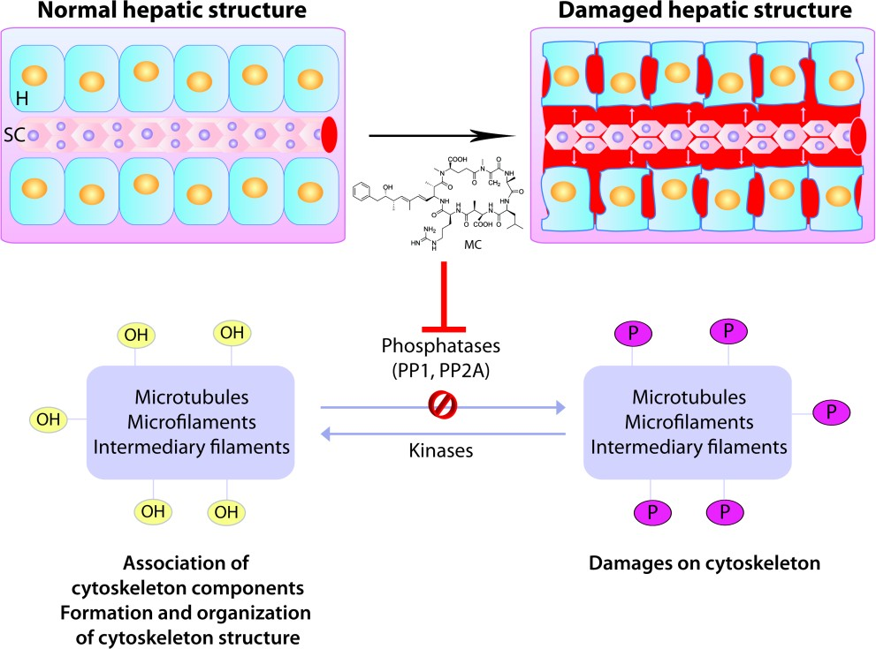

Figure 2. Representation of the effects of microcystins in the cytoskeleton, namely the changes of the hepatocytes and sinusoidal capillary structure, and intrahepatic bleeding, mediated by the inhibition of protein phosphatases PP1 and PP2A. Legend: H – hepatocyte; SC – Sinusoidal capillary; MC – microcystins; OH – hydroxyl group; P – phosphate group; PP1 – protein phosphatase 1; PP2 – protein phosphatase 2.

Research objectives

We hypothesize that detecting the different types of SARS-CoV-2 variants through single nucleotide polymorphism (SNP) genotyping that induces potential oxidative stress and affects the immunity/health status through its toxic impact of 160 hospitalized Covid-19 patients, and evaluating anti-viral therapy using Vero E6 cell line exposed to the different variants of coronaviruses.
The study will be conducted by performing the following laboratory tests:
- Detecting SARS-CoV-2 variants with SNP genotyping. (Proposed to be done when funded)
- Genome sequencing of the 322 selected positive RNAs SARS-CoV-2 samples. (Proposed to be done when funded)
- Evaluation of antiviral efficacy assay: Remdesivir: Using Vero E6 cells

(Proposed to be done when funded)
- Evaluation of polypharmacy potential impacts of patients using the Swiss Target Prediction website.

(An article: under processing to be done in March)
- Detection of coronavirus by RT-PCR. (Completed)

The following evaluation of the toxic effects of coronavirus by analytical instrumentation has been done:
  - Clinical pathological changes to detect toxic effects (e.g., Cytokines “IL-6”, Liver function tests, Renal function test, C-Reactive protein “CRP”, Lactate dehydrogenase, Serum ferritin, D-Dimer, Complete Blood Count, and Serum electrolyte). (Completed)
  - The oxidative stress assay has been assessed using the following measurements:
    - Serum total antioxidant status (TAS). (Completed)
    - Serum malondialdehyde (MDA). (Completed)
  - Cholinesterase activity in the blood and its susceptibility to inhibitors. (Completed).

Sample Size: 322 RNAs, positive samples of SARS-CoV-2 virus.
(RNA extraction performed using Nucleic acid isolation system EXM3000 and dedicated extraction Zybio kits).
https://www.dlongwood.com/en/products/nucleic-acid-isolation-system-exm3000/

Kind Regards.


Ghazwan Ahmed Mohammed Raouf PhD Candidate-ERASMUS+ Mobility Program Università degli Studi della Tuscia-Viterbo-Italy
http://www.unitus.it ghazwan.ahmed@unitus.it Mobile: +393897806948

