Process intensification and optimization for sonocrystallisation of uranium peroxide
Shrishma Paik*, SK Satpati and DK Singh
Bhabha Atomic Research Centre, India
Abstract
Peroxide precipitation is an emerging process in nuclear technology and one of the well-known methods for production of first intermediate uranium compound before uranium bearing fuel production. Though the conventional method of precipitation is practiced worldwide, it suffers from the limitation of non-uniform particle formation and lesser control over particle growth and size. Hence there is always a scope to study the effect of novel technique for process intensification. Application of ultrasound or sonochemical technique is one of the techniques which can intensify the crystallization event to a large extent by the impact of its cavitational process imparting micro mixing, enhanced mass transfer and the effect of additional spontaneous nucleation. It also facilitates in enhancing the crystal shape and size with better consistency and can control physical and morphological characteristics of the powder in several ways. Here, study was carried out for establishing important process parameters namely uranium cocn and temperature for ultrasonic precipitation compared to conventional methods in laboratory scale with an ultrasound horn at 35 KHz. Uranyl nitrate with 30% hydrogen peroxide was used for the reaction in 1 liter scale. No appreciable difference in the phases has been found from the XRD study [Figure 1]. However a more homogeneous, regular and smooth crystalline appearance is observed in sonochemical precipitation route compared to conventional route under SEM study at 100 g/L uranium with 60ºC temperature [Figure 2]. The crystal shape is rhombohedra with a spherical aggregation in comparison to needle shaped crystals in conventional route. Significant improvement is also seen in specific surface area and tap density of the prepared powder in sononchemical route. The powders obtained from this novel technique are having recovery more than 99.9% w.r.t. uranium. The purity of the synthesized powder also meets the specification of nuclear grade quality. Overall, the sonochemical method of precipitation of uranium peroxide is a fast, simple, convenient and intensifying technique imparting appreciable morphology and physical characteristics over the conventional precipitation process.
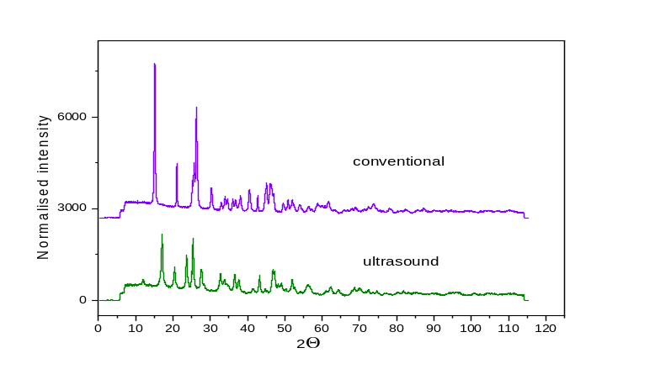
Figure 1. XRD profile of uranium peroxide.
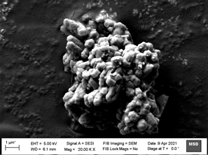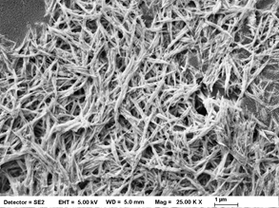
Figure 2. SEM pictures of Uranium peroxide in sonochemical and conventional route.
Keywords: Precipitation, Uranium peroxide, Morphology, Ultrasound, Cavitation.
Biography
Shrishma Paik is currently working in the field of nuclear technology on separation and recovery of uranium from different sources. Her development area involves intensification of process of uranium by precipitation as well as solvent extraction by novel techniques and minimization of waste volume during uranium refining process.

