Assessment of iron status among infants aged six to nine months at soy division Keiyo South Sub County
Onyangore, F.O.
University of Kabianga, Kenya
Abstract
The increased prevalence of iron deficiency among infants aged 6 and 24 months can be attributed to the consumption of an iron deficient diet or a diet that interferes with iron absorption at the critical time of infancy. The objectives of the study were to determine iron status among infants, to determine dietary intake of complementary foods by the infants and to ascertain the complementary feeding in Keiyo South Sub County. The cross-sectional study design was adopted. The study was conducted at Soy division in Keiyo South Sub County at Biretwo, Cheptebo and Sego health facilities. Systematic sampling procedure was used to select 136 subjects. In the second year, 54 mothers were followed up due to loss of subjects. The 24 -hour recall generated data on dietary iron intake. Biochemical tests were carried out by use of the portable Hemo_Control Photochrometer [Figure 1] device at the health facilities. Data was analyzed using SPSS computer software version 17, 2009.
Results showed that 28.7% of the infants had mild anemia whereas 23.5% had moderate anemia. The mean iron intake was 10.59 ± 1.71 mg/day. Most (94.1%) of the mothers were still breastfeeding but on the contrary, 45.6 % of all the mothers fed their infants on tea which is an iron inhibitor. None of the infants had received iron supplements. Policies for screening infants for iron deficiency during the first year of life should be developed as the iron deficiency anemia is a problem in Kenya.
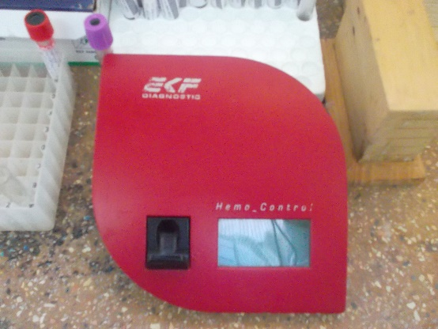
Figure 1. Hemo_Control Photochrometer @ Biretwo Health Center.
Biography
Faith is currently undertaking her postdoc at Nottingham, UK. She holds a PhD in Environmental Health (Food Toxicology and Nutrition), Master of Science in Community Nutrition and Bachelor of Science in Environmental Health. She has practiced as a public health officer in the Ministry of Health and is a lecturer and Head of Department Public health at the school of Health science, University of Kabianga, Kenya. Her research interests focus on iron and other micronutrients, considering their interactions with toxins and toxicants and how this may impact upon maternal and child health and have vastly published. She has further been a health consultant in various organizations including the Africa Medical Research Foundation (AMREF). She does community service in maternal and child health and nutrition and hopes that she will further translate her current research findings into policies. She networks widely in institutions, individuals from different disciplines, backgrounds and nationality.

