GOS consumption optimizes gut health and Short Chain Fatty Acid (SCFA) profile of sedentary constipated adults: A double blind randomized placebo controlled clinical trial
Kankona Dey* and Mini Sheth
The Maharaja Sayajirao University of Baroda, India
Abstract
Galactooligosaccharide are prebiotics that changes the composition of gastrointestinal microbiota conferring bifidogenic effect on the gut. The purpose of this study was to assess the impact of Galacto-Oligo-Saccharide (GOS) gummies’ supplementation on gut health and constipation profile of sedentary adults. University teaching faculty who were constipated (n=35) were screened using validated pre-tested questionnaires. Eight parameters were studied including Rome IV criteria, WHO definition and Bristol Stool Chart. They were subjected to a double blind placebo controlled clinical trial (Figure 1). The participants were split into two groups; the experimental group (n=17) received 100% GOS gummies, while the placebo group (n=18) received sugar gummies for 30 days. Fecal samples were collected at baseline and Day 30. The relative abundance of genera including Bifidobacterium, Lactobacillus, Clostridium, Bacteroides and phyla Bacteroidetes and Firmicutes were examined using Real-Time PCR. Normalization of gene expression was done using 16s rRNA. SCFA profile was studied using gas chromatography technique with respect to Acetic acid, Butyric acid and Propionic acid as SCFA is linked with increased colonization of beneficial bacteria. The experimental group experienced a significant increase in stool frequency by 40% (p<0.01) and significant reduction of gastrointestinal symptoms. In contrast to the placebo group, the results showed a significant increase in the genera Bifidobacterium (p<0.001), Lactobacillus (p<0.001) in the GOS supplemented subjects. However, genus Clostridium (p<0.01), phyla Firmicutes (p<0.001) and Bacteroidetes (p<0.001) were found to be reduced significantly, particularly in the GOS supplemented group. In comparison to the placebo group (1.29), it was observed that the GOS supplemented group had a higher F/B ratio (2.57) which correlates to an improved gut health. Significant increase in Acetic acid (p<0.001) and butyric acid (0.01) was observed among the experimental group making it evident that short-term GOS consumption can relieve constipation status and result in improved gut health profile of constipated subjects.
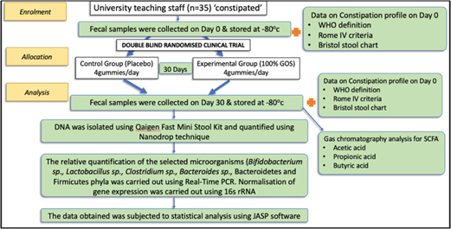
Figure 1. Methodology for double blind randomized clinical trial.
Biography
Kankona Dey is a PhD scholar in the Department of Foods and Nutrition, The Maharaja Sayajirao University of Baroda, India working in the area of prebiotics and gut health. She is an active member of recognized Indian membership bodies including Nutrition Society of India, Indian Dietetic Association and National Institute of Nutrition, Hyderabad, India is her Alma matter. She is a certified diabetes educator and a bariatric nutritionist with a work experience of over 6 years. Currently she has two book chapters and two published Scopus indexed research papers to her credit. She has a consistent academic record with zeal to learn new concepts quickly and apply innovative ideas for achieving best results. She is motivated, self-starter with a passion to succeed and desires to excel in the areas of food and nutrition.

