Cleft hard and soft palate with unilateral cleft lip: A Case report from practice
Rohit Rathore, Alikya Chipurupalli and Nana Jincharadze
University, Country
Abstract
Background: Oro-Facial Clefts (OFC) due to failure of fusion of frontonasal and maxillary processes can result in cleft lip or failure of fusion of palatal shelves can result in cleft palate isolated/combined. NCDC Georgia statistics reported 4 new cases of OFC per 100000 in 2019. The etiology of OFC is multifactorial including genetic and environmental factors like smoking, alcohol and folic acid deficiency during pregnancy. Complications include ear infections, feeding difficulties, speech impairment, aspiration of food, choking, frequent pneumonia and dental problems. The aim of this study is to present a case report of a patient with OFC and highlight the need for high vigilance and knowledge of ultra-sonographers for antenatal detection so as to counsel parents and train mothers. Additionally, it highlights the need for skilled surgeons to perform timely intervention in developing countries like Georgia.
Methods: A qualitative and systematic case report study was performed on OFC. Databases such as Google Scholar, PubMed, Ebsco and official websites of WHO, NCDC and CLAPA were used to summarize, interpret and analyze the case report.
Results: A newborn male delivered at 37th week of gestation via Caesarean Section presented with Orofacial cleft as seen [Figure 1]. The child weighed 3300 gm, was appropriate for gestational age (50th%) and had an Apgar score of 8/8. The length, chest and head circumference were 50 cm, 35 cm and 33 cm respectively. The body temperature, pulse, respiratory rate and SaO₂ were 36.6,148,50 and 98% respectively. Amniotic fluid, Brain Ultrasound scan were unremarkable with weak primitive reflexes. CBC (Complete Blood Count), CRP (C-Reactive Protein), TBS (Total Bilirubin Serum) were normal. The child was A+ and feeding was initiated by orogastric tube followed by a special nipple bottle after training the mother. Slow feeding of newborn (P92.2) and Cleft hard and soft palate with unilateral cleft lip (Q37.5) were diagnosed postnatally despite multiple antenatal ultrasound screening. Currently the baby is undergoing 2nd level of newborn care nursery. The parents have undergone Paediatric Orthognathic Surgeon consultation and surgical correction of lip is scheduled at 4 months, whereas for palate it is not yet planned.
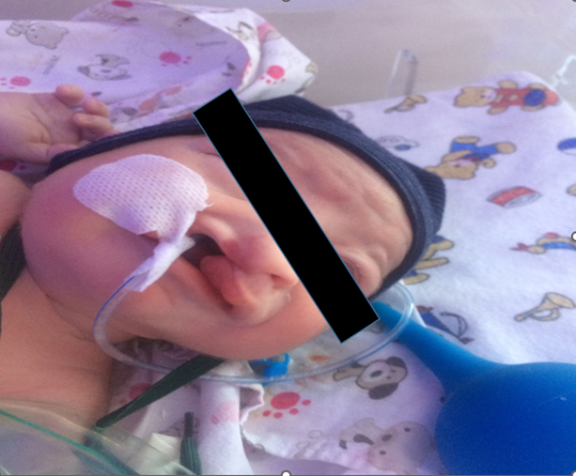
Figure 1. Orofacial cleft.
Conclusion: OFC has a life changing influence on the child and family’s psychological health, quality of life and socioeconomic status. This condition requires a multidisciplinary team which can incur high health care costs. CLAPA (Cleft Lip and Palate Association) reports that most cases are impossible to pick up antenatally through regular scanning leading to frequent missed diagnoses as seen in this case. Therefore, adequate training and high vigilance of the ultra-sonographers and physicians about the embryology of facial development is important to identify high risk groups so as to perform additional investigation like fetal MRI to confirm the diagnosis. Early diagnosis of OFC is essential for parental training about special maternal feeding techniques which lacked in this case and psychologist counseling for preventing long term mental trauma. Early surgical correction (correction of lip in 2-month, correction of cleft between 6-24 month or later) is recommended for scar healing and appropriate speech/language development but as in this case, the surgical management is being delayed pressing on the need for highly skilled surgeons in developing countries like Georgia.
Keywords: Orofacial clefts, Cleft lip, Pediatric orthognathic surgery, Cleft palate.
Biography

