Emerging connection of the mental health and well-being axis with digital technology: A quantitative and qualitative study
Arianna Alejandra Andino¹*, Jeanne Joehler² and Moin Rahman²
¹University of Illinois at Urbana-Champaign, USA
²State Farm Insurance and Financial Services, USA
Abstract
Background: The COVID-19 pandemic exacerbated mental health concerns and highlighted the potential for digital platforms and services to provide support beyond the clinical setting. Given patients may have financial hardships, limited workforce capacity and/or lack of access to care, there is a tremendous gap in mental health care in the United States. Expanding access through tele-health and leveraging technology have the potential in addressing this gap.
Objective: The aim of this study is to investigate the role and landscape of digital technologies in mental health management and treatment using a mixed-methods approach involving both qualitative and quantitative research.
Methods: Through a four-stage research process, the authors analyzed several factors, including the experience of young adults (1100 participants) with digital mental health tools, preferences and perceived value in tools and services, reasons for abandonment and increased interest in using tele-health services [Figure 1].
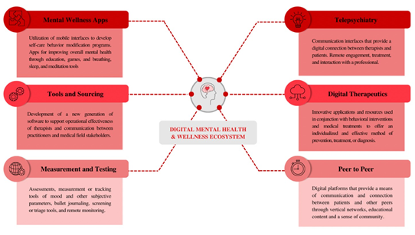
Figure 1. Digital mental health ecosystem.
Results: The findings suggest young adults who engage in digital mental health tools view these tools as an effective way to decrease obstacles of traditional mental health services and strengthened engagement in the long-term use of the mental health strategies.
Conclusions: Consequently, this study highlights the growing presence of digital mental-health technologies that include tools, features and resources as well as the perceived as benefits, value and usefulness. The findings have implications for building awareness within the behavioral younger generation’s use and beliefs around these tools. Finally, this paper encourages deeper development of multipurpose, evidence-based research and determines the value and efficacy of mental health digital platforms.
Biography
Arianna Andino is an Enterprise Research analyst, has expertise in the research process and data analysis of several different areas, particularly in the tele-mental health axis. With a mixed-method approach, she has a passion for the examination of the function and landscape of digital technology in mental health management and treatment. Based on an extensive literature review, she has built a digital mental health and well-being ecosystem that serves as a framework to understand the emerging connection between mental health and digital platforms and services.

