What is the role of ERCP in the diagnosis of hemosuccus pancreaticus?
Kwak Yun Mi*, Paik Kyu-hyun, Kim Ji Chang and Park Won SuK
Catholic University of Korea, South Korea
Abstract
Hemosuccus Pancreaticus (HP) is one of the rare causes of gastrointestinal bleeding, sometimes leading to a life-threatening condition. However, the diagnosis of HP is often delayed as its rarity and intermittent signs of bleeding, which still is challenging to determine the bleeding source for some patients. An 83-year-old man was transferred to our hospital to evaluate the source of intermittent upper gastrointestinal bleeding involving melena and worsening anemia. Initial upper and lower gastrointestinal endoscopies could not reveal any source of bleeding. Emergent upper endoscopy performed with hematochezia and hypotension confirmed a spurt of bleeding from the major duodenal papilla [Figure 1A]. However, contrast-enhanced CT and angiography could not find the source of the bleeding from the major duodenal papilla. Here, Endoscopic Retrograde Cholangio Pancreatography (ERCP) for inducing the bleeding from the source and indicating the bleeding point was performed according to the decision of the multidisciplinary team [Figure 1B]. Immediately thereafter, sequential angiography was performed, and HP due to the rupture of a pseudoaneurysm of the splenic artery could be diagnosed [Figure 1C]. As a result, it was possible to avoid surgical resection of the pancreas by accurately embolizing the bleeding focus of HP under a multidisciplinary team approach. The patient was discharged in a hemodynamically stable condition. There was no further gastrointestinal bleeding or procedure-related complications till 6 months of discharge.
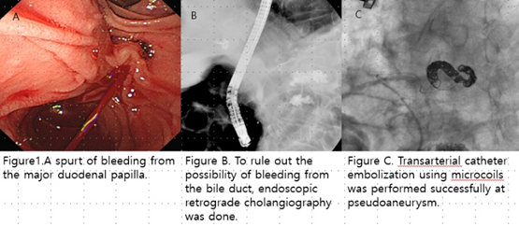
Figure 1. A. Spurt of bleeding from the major duodenal papilla. B. To rule out the possibility of bleeding from the bile duct, endoscopic retrograde cholangiography was done. C. Transarterial catheter embolization using microcoils was performed successfully at pseudoaneurysm.
Biography
Kwak Yun Mi graduated medical school and trained about internal medicine until now, she is training fellowship of catholic hospital of Republic of Korea. She has interest in gastroenterology part of internal medicine and she hope that she will be a professional doctor of internal medicine of gastroenterology.

