FUSE (Full-Spectrum Endoscopy): Next step to have “GADGET” function
Jeong-Yeop Song*, Hyun Ju Park, Hyun Joo Shin, Jeonghyun Ahn and Kyeong Eun Lee
Seongnam Citizens Medical Center, Republic of Korea
Abstract
For the past about 60 years, since the first introduction of fiberscopes and subsequent video scopes, there has been only one-type of endoscopes, that means standard forward-view type endoscopes including only one single lens with 140-170° angle of view.
In contrast to that, recently introduced FUSE (Full-Spectrum Endoscopy) endoscopes include multiple lenses, providing much wider field of view, especially two lenses with 245° in gastroscope, three lenses with 330° in colonoscope (Figure 1).
FUSE is feasible/effective/safe, and FUSE colonoscopy yielded higher PDR/ADR/DDR (Polyp/Adenoma/Diverticula Detection Rate) than did traditional colonoscopy, without therapeutic failure or complications (Table 1).
Table 1. ADR between FUSE vs traditional colonoscopy.
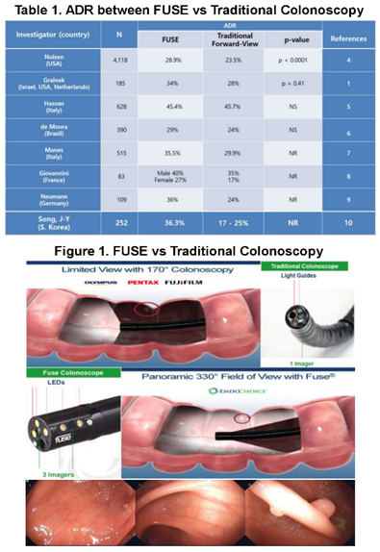
Figure 1. FUSE vs traditional colonoscopy.
Moreover, using FUSE gastroscopy, the prevalence of DPAD (Duodenal Peri-Ampullary Diverticula) in the general population could be analyzed without using ERCP (Figure 2).
But still there is only one working channel inside the scope yet. So, if any lesion or polyp might be found at the side-lens portion, endoscopists have to manipulate the endoscope to approach the lesion, necessitating the time and the skill.
However, if there are additional working channels on both sides of the FUSE colonoscope, we can remove the polyps with more comfort and lesser time (Figure 3-top).
Even more, additional working channel at the side-lens portion of FUSE gastroscope would make it possible to insert the baby scope, such as Spy-glass DS, through the side-working channel (Figure 3-bottom).
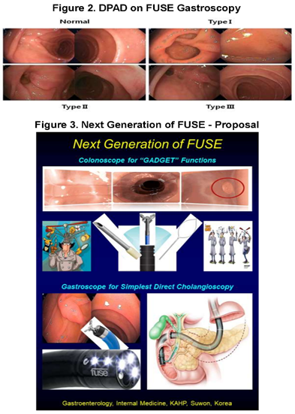
Figure 2. DPAD on FUSE gastroscopy.
Figure 3. Next generation of FUSE-proposal.
Therefore, with the aid of the side-working channel on FUSE gastroscope, it would be possible to make a cannulation into the papilla with that baby scope, which means direct per-oral cholangioscopy could be enabled.
In the future, next generation of modified FUSE gastroscopy is expected to be useful in direct per-oral cholangioscopy without radiation exposure, and looking for “GADGET” colonoscopy.
Biography
Jeong-Yeop Song grew in Korea and graduated from A-jou school of medicine, and obtained his PhD degree from Soon-Chun-Hyang University. In 2010-2011, he has worked at Karolinska Institute, Sweden, as a research fellow studying irritable bowel syndrome and colonic diverticula. He is a member of the Korean Society of Gastroenterology, and Gastrointestinal endoscopy. His major specialty is irritable bowel syndrome. He has received various awards, including Poster of Distinction in DDW and Best Video Award in IDEN in 2012 as well, and Moderate Poster in APDW in 2015. Currently, He is the chief of division of gastroenterology, department of internal medicine of Seongnam Citizens Medical Center (SCMC) in Seongnam, Korea. Also he has been the first and the only one who use FUSE endoscope system in Korea, and published the paper and made a lot of presentations about FUSE system.

