Thermo responsive surfaces designed for the proliferation and differentiation of human pluripotent stem cells
Akon Higuchi, Abdurahman H. Hirad*, S. Suresh Kumar, Murugan A. Munusamy and Abdullah A. Alarfaj
King Saud University, Saudi Arabia
Abstract
Thermo responsive surfaces enable the detachment of cells or cell sheets by decreasing the temperature of the surface when harvesting the cells. However, Human Pluripotent Stem Cells (hPSCS), such as embryonic stem cells and induced pluripotent stem cells, cannot be directly cultured on a thermo responsive surface; hPSCs need a specific extracellular matrix to bind to the integrin receptors on their surfaces. We prepared a thermo responsive surface by using poly (N-isopropylacrylamide-co-butylacrylate) and recombinant vitronectin to provide an optimal coating concentration for the hPSC culture. hPSCs can be cultured on the same thermo responsive surface for 5 passages by partial detachment of the cells from the surface by decreasing the temperature for 30 min; then, the remaining hPSCs were subsequently cultured on the same dishes following the addition of new cultivation media. The detached cells, even after continual culture for five passages, showed high pluripotency, the ability to differentiate into cells derived from the 3 germ layers and the ability to undergo cardiac differentiation [Figure 1].
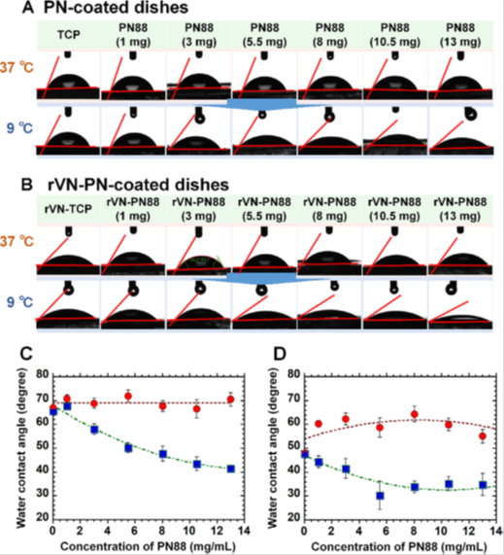
Figure 1. The response of the hydrophobicity-hydrophilicity of the thermo responsive PN88-coated plates to temperature. (A) Photos of water droplets evaluated by the sessile drop method performed on the TCP, PN88(1)-TCP, PN88(3)-TCP, PN88(5.5)-TCP, PN88(8)-TCP, PN88(10.5)-TCP, PN88(13)-TCP plates at 37°C and 9°C. (B) Photos of water droplets evaluated by the sessile drop assay performed on the TCP, rVN-PN88(1)-TCP, rVN-PN88(3)-TCP, rVN-PN88(5.5)-TCP, rVN-PN88(8)-TCP, rVN-PN88(10.5)-TCP, rVN- PN88(13)-TCP plates at 37°C and 9°C. (C) The water contact angle on the TCP, PN88(1)-TCP, PN88(3)-TCP, PN88(5.5)-TCP, PN88(8)-TCP, PN88(10.5)-TCP, PN88(13)-TCP plates at 37°C (red circle) and 9°C (blue square). (D) The water contact angle on the rVN-TCP, rVN-PN88(1)-TCP, rVN-PN88(3)-TCP, rVN-PN88(5.5)-TCP, rVN-PN88(8)-TCP, rVN- PN88(10.5)-TCP, and rVN-PN88(13)-TCP plates at 37°C (red circle) and 9°C (blue square).
Biography
Abdurahman H. Hirad has been actively involved in research mainly in the field of Molecular Microbiology, Nano-biotechnology, Environmental and Applied Microbiology. In a more general, sense her research interest spans across the following fields: biological sciences, industrial microbiology, medical biotechnology, materials sciences, environmental biotechnology, industrial biotechnology, nanotechnology, medical Biotechnology, and molecular microbiology.

