Gastrocnemius and soleus skeletal muscle proteomic changes of Type 2 Diabetes Mellitus (T2DM) after exercise interventions in db/db mice
Monika Renuka Sanotra¹*, Yen-Chun Huang², Ting-Yu Chen³, Yi-Ju, Hsu², Chi-Chang Huang² and Chen-Chung Liao⁴
¹Taipei Veterans General Hospital, Taiwan
²National Taiwan Sport University, Taiwan
³Marker Exploration Corporation, Taiwan
⁴National Yang Ming Chiao Tung University, Taiwan
Abstract
Objective: Exercise is a modifiable risk factor that may affect the gastrocnemius and soleus muscle protein level in the T2DM mice model. To investigate this hypothesis, we performed blood examination and proteomics analysis of the skeletal muscle of wild-type mice and diabetic mice with and without exercise training.
Method: Inclusion criteria for control and diabetic mice were four male ICR mice per group aged 8 weeks. The three groups consist of 1) Wild Type (WT), 2) Sedentary Control Diabetic Mice (SED) without exercise and 3) diabetic mice with Exercise Training (ET) for six weeks Body weight, HbA1c level before and after exercise intervention, weekly blood glucose monitoring, fatigue test (forelimb grip strength), organs or tissue weight and biochemical tests. Gastrocnemius and soleus muscles were further used for proteomic analysis by using liquid chromatography and tandem mass spectrometry after tryptic digestion. Proteomic data interpretation was performed by using Peaks 7 software and bioinformatics tools.
Result: Blood glucose and HbA1c level were decreased significantly in the ET mice group than in SED. Grip strength was reduced in the ET group compared to the WT group, which indicates it may be due to exercise tiredness. Muscle weight and biochemical tests were recorded after sacrificing mice. Insignificant gastrocnemius muscle gain was seen in ET mice more than in SED. Various Differential Expression Proteins (DEPs) were observed in proteomics data having biological functions related to free radical scavenging, skeletal-muscular disorders, metabolic disease and lipid metabolism. Due to exercise intervention, intermediate products and enzymes involved in metabolic activity level change in skeletal muscle could be potential biomarkers for T2DM disease prevention, mitigation and treatment [Figure 1].
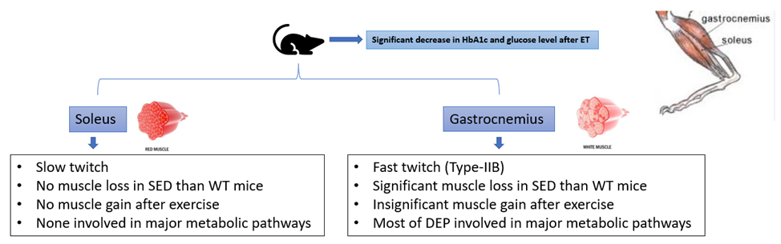
Figure 1. Effects of exercise intervention on gastrocnemius and soleus muscle of db/db mice.
Conclusion: As per our research data, we successfully established a diabetic mice model for skeletal muscle proteomic analysis, which mimics human pathological conditions. We also found lists of DEPs that significantly affect T2DM symptomatic improvement.
Keywords: Exercise training, Proteomics, Skeletal muscle, Type 2 Diabetes Mellitus (T2DM).
Biography
Monika Renuka Sanotra has done her master in pharmaceutical chemistry from Jamia Hamdard University, India, PhD from Taipei medical University. She is a Post-doctoral at TVGH. Her working experience includes Drug regulatory affairs and drugs testing at Indian FDA laboratory, Worker with Tosoh bioscience as application scientist for HPLC column troubleshooting and Major disease biomarkers.

