Fabrication and characterization of cross-linked CMC/PVP-co-poly (AMPS) based hydrogel for the sustained release of model drug metoprolol tartrate
Akram Ashames¹*, Fahad Pervaiz², Moawia Al-Tabakha¹, Kanza Khalid², Nageeb Hassan¹, Hina Shoukat², Manal Buabeid¹ and Ghulam Murtaza³
¹Ajman University, United Arab Emirates
²The Islamia University of Bahawalpur, Pakistan
³COMSATS University Islamabad, Pakistan
Abstract
This research aims to fabricate and characterize chemically cross-linked CMC/PVP-co-poly (AMPS) based hydrogel for the sustained release of model drug metoprolol tartrate through free radical polymerization technique. CMC/PVP-co-poly (AMPS) hydrogels were formulated by the free radical polymerization technique. Carboxymethyl cellulose is crosslinked chemically with AMPS with a constant ratio of PVP by the ethylene glycol dimethacrylate as the cross-linker in the existence of sodium hydrogen sulfite/ammonium peroxodisulfate as initiators. CMC based hydrogels were fabricated by using different concentrations of polymer, monomer, and cross-linker. Dynamic swelling, sol-gal fraction, and percent drug release were performed along with some characterizations such as FTIR, XRD, TGA, DSC, and SEM. In-vitro drug release and swelling were performed at 1.2 and 6.8 pH to determine the sustained release pattern and pH-responsive behavior. These parameters are directly linked with the different ratios of cross-linker, polymer, and monomer. XRD, SEM, and FTIR show the successful grafting of constitutes and formation of a stable hydrogel. While the DSC and TGA confirm the thermodynamic stability of the hydrogel. The swelling of hydrogels increases as the ratio of monomer rises while decreases with a rise in the ratio of polymer and cross-linker. In-vitro gel fraction and drug release also depend on the ratios of polymer, monomer, and cross-linker. CMC/PVP-co-poly (AMPS) hydrogels can be considered as the potential system for the sustained delivery of model drug metoprolol tartrate for prolonged disease treatment with reduced dosing frequency and enhanced patient compliance. Box-Behnken Design was used to optimize CMC/PVP-co-poly (AMPS) hydrogel by varying the content of reactants such as; polymer (CMC), monomer (AMPS), and crosslinker (EGDMA) [Figure 1].
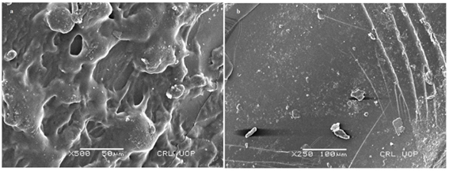
Figure 1. SEM image of loaded (a) and loaded (b) CMC/PVP-co-poly (AMPS) hydrogels.
Biography
Akram Ashames has 25+ years of proven experience in university teaching and research, pharmaceutical sciences, cancer research, and nano-biomaterials. He has R&D accomplishments in drugs development and separation techniques of biological materials. He has Hands-on experience in pharmaceutical quality control, quality assurance, and biomaterial separation and characterization. He is experienced in pharmaceutical analytical methods, pharmaceutical laboratories, and pharmacy-based policy development and management.

