Effectiveness of supply chain planning in ensuring availability of CD/NCD drugs in non-metropolitan and rural public health system
Nagarajan Shyama
SahaManthran Pvt Ltd, India
Abstract
Statement of the problem: Several studies have reported on the shortage of drugs with the changing demographic and disease profile, especially triggered by the growing burden of lifestyle diseases in India. However, very few have evaluated the demand side challenges from the objective of universalization of healthcare. Therefore, this study was designed to evaluate the factors that have impeded access to affordable generic and essential drugs in non-metropolitan urban and rural India.
Methodology & theoretical orientation: The study was conducted in six states and responses were elicited from a sample of doctors, pharmacists, nurses, ASHA workers, state officials, warehouse managers and patients across the study states of India.
Findings: The study reveals that while the acceptance of prescribing generic drugs has improved over the last decade, the use of branded drugs has been restricted only to complex cases or where generic drug efficacy has not been established. The centralized (state) procurement efficiencies seem to have hit a plateau in terms of assuring drug availability to the last mile, thereby necessitating costlier local purchase. Most states have also established dedicated corporations for drug procurement, albeit at different levels of organizational maturity as far as adherence to the processes and (IT) systems are concerned. However, supply chain phenomena like the bullwhip effect gets accentuated given the levels of our public health system. Learning’s from other consumer facing sectors with similar challenges of increased variability and uncertainty are yet to be explored for the health sector to leapfrog towards achieving improved ‘drug availability’ OR ‘zero stock-out’ [Figure 1].
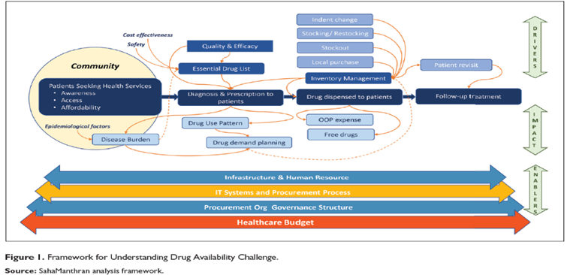
Figure 1. Framework for understanding drug availability challenge.
Conclusion: Standardizing drug categories, regular updating of the Essential Drug List (EDL) reflecting the demographic and disease profile, various practices like complete digitalization, rolling forecasts, SKU rationalization, flexible public procurement contracts, etc., have been explored as potential solutions in this paper. Creating a dedicated team of forecasters within the procurement organizations, well adept at using analytics, could be a key to real-time demand estimation, paving the way for a quarterly rolling forecast to facilitate procurement using well-designed and flexible rate contracts with suppliers that captures variability in such rolling forecasts.
Biography
Shyama is a medical Graduate, equipped with a dual Master’s degree in Hospital Administration from All India Institute of Medical Sciences and Public Health from National Board. Having served in leadership positions at prestigious institutes like that of the World Bank, ICRA, Fortis Healthcare, Ernst and Young she has over 25 yrs of multi-faceted experience in both public and private sector including multi-lateral and donor partners. Currently, she serves at SahaManthran Pvt Ltd, a niche healthcare consulting firm as Managing Director and has over 65 national and international publications in peer-reviewed journals to her credit. She has the credit of pioneering the Grading of health services in India, during her stint in India, which served as inputs into development of NABH accreditation process.

