Mental health and physical activity have diminished during the pandemic: A narrative literature review
Christina Amo
Texas A&M University, USA
Abstract
Mental Health (MH) and Physical Activity (PA) share a bidirectional relationship throughout the literature. Most studies examine PA’s impact on MH; however, the reciprocal effect is not as commonly reported. With pandemic-related diminished MH, this review opportunistically evaluates how MH may affect PA. To identify relevant literature, electronic databases such as MEDLINE, PsycINFO, and CINAHL were searched for English language articles in peer-reviewed journals using search terms equivalent index terms: “anxiety,” “depression,” “stress,” “mental health,” “exercise,” “activity,” “walking,” “running,” “cycling,” “COVID-19,” “coronavirus,” “2019-NCOV,” “SARS-COV-2,” “COV-19,” and “2019 pandemic” to ensure broad coverage. Included were peer-reviewed published articles that reported PA as the outcome and MH as the indicator, articles that directly correlated PA and MH, and occurred during COVID-19. Extracted from final 21 articles were: country of the study, study design, study aim, sample size, gender, and education as well as MH and PA assessment tools, and key findings. The common MH themes the impacted PA were pre-existing depression or anxiety (n=8), stress due to the pandemic (n=5), and social isolation or confinement (n=8). Reviewed articles supported that deteriorating MH may precede diminished PA. Women, especially those responsible for the health of their families, seem to suffer the greatest from diminished MH and PA health throughout the pandemic. Current research suggests that previous MH concerns pre-pandemic seem to have more coping skills and fewer adverse effects from COVID-19 than expected. As we emerge from this pandemic, targeting MH support may accelerate a seamless return to PA. Timely and strategic efforts are critical to mental and therefore physical recovery. Health programs aimed to improve physical health would do well to consider one’s post-pandemic mental health status. Future studies could identify if including MH education into school curriculum would provide coping skills to use when highly stressful situations are experienced later in life [Figure 1].
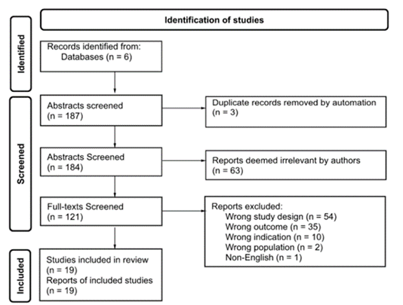
Figure 1. PRISMA flow diagram detailing the number databases searched, abstracts and full texts screened and included.
Biography
Christina Amo has her expertise in social networks and mental health relative to physical activity and exercise. Her background in psychology and exercise science gives her a unique approach to physical activity and other health behaviors. Her passion is to evaluate physical activity behaviors relative to interpersonal and intrapersonal environments.

