Glomus tumor- A rare lesion with a typical presentation
Javeriya Fatima
Grant Medical College, India
Abstract
A young boy presented with tenderness of the index finger tip with pain on exposure to cold and reddish discoloration of the finger pulp. A clinical diagnosis of glomus tumor was made and patient referred for preoperative radiological imaging. The exact location and size of the pulp glomus tumor was identified on imaging which assisted complete removal safely. This case aims to reflect a rarely involved site of glomus tumor in the finger pulp.
Case presentation: A young boy presented with tenderness of the index finger tip for more than 2 years. He also had also had attacks of pain with exposure to cold. There was red discoloration on the fingertip involving the pulp. Ultrasonography showed a hypoechoic nodular lesion showing vascularity on color doppler. Magnetic resonance imaging showed a well-circumscribed mass at the same site. It was iso-intense to hypo-intense on the T1-weighted image and hyperintense on the T2-weighted image with intense post contrast enhancement [Figure 1]. Radiography showed subtle volar bone erosion in the distal phalanx [Figure 2]. Surgery was performed. Histologically the diagnosis of a glomus tumor was made.
Discussion: Glomus tumours are benign lesions with high morbidity with involvement in the order of subungual followed by median and lateral folds, pulp and lastly proximal nail folds. The preoperative knowledge of the exact site and the size of the tumor help in selecting the surgical method with complete excision of the tumor, reducing the rate of recurrence. MR is very useful for differentiating a glomus tumor from other important differential diagnoses like hemangioma, angioleiomyoma and epidermal inclusion cyst. The imaging characteristics of our case were of a typical glomus tumor, but the site of involvement was atypical. The characteristic clinical and MR features helped in the diagnosis of this benign entity at a rare site involving finger pulp.
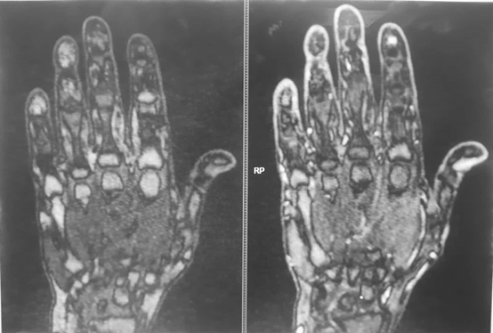
Figure 1. T1 weighted, pre and post-gadolinium, fat saturation images demonstrating the 2x4 mm enhancing glomus tumor at the pulp of right index finger.
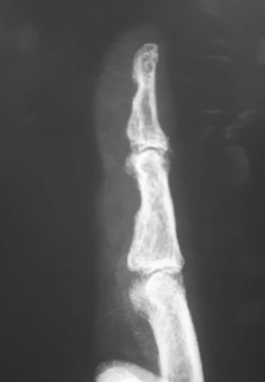
Figure 2. Lateral radiograph depicting subtle erosion of underlying distal phalanx.
Conclusion: The glomus tumor is a relatively rare yet characteristic abnormality that may present as a fingertip mass. Clinical presentation and specific MR imaging characteristics allow a definitive diagnosis. MR provides valuable confirmation and localization of the lesion prior to resection.
Biography
Javeriya Fatima has many years of academic experience in the field of Medical Radiology Imaging Technology. She is a Research scholar, M.Sc. & B.Sc from Grant Medical College, Maharashtra, India. Presently she is working at JJ hospital, India.

