Selective GSK3β inhibition mediates an Nrf2-independent anti- inflammatory microglial response
Mohamed H. Yousef, Mohamed Salama, Hassan A. N. El-Fawal, and Anwar Abdelnaser*
The American University in Cairo, Egypt
Abstract
Glycogen Synthase Kinase 3 (GSK3) is associated with the pro-inflammatory phenotype of microglia and has been shown to act in concert with Nuclear Factor kappa B (NF-κB). GSK3 is also a suppressor of Nuclear factor erythroid 2-related Factor 2 (Nrf2), the principal regulator of redox homeostasis. Agreeing with the oxidative paradigm of aging, Nrf2 is often deregulated in para-inflammatory and neurodegenerative diseases. In this study, we aimed to explore a multimodal disease-modifying utility of GSK3 inhibition, beyond neuronal proteopathologies, Furthermore; we aimed to underscore the difference in therapeutic value between the two GSK3 paralogs by isoform-selective chemical inhibition.
The anti-inflammatory effects of paralog-selective GSK3 inhibitors were evaluated as a function of the reductive capacity of each to mitigate LPS-induced activation of SIM-A9 microglia. The Griess method was employed to detect the nitrate-lowering capacity of selective GSK3 inhibition. Real-time PCR was used to assess post-treatment expression levels of pro-inflammatory markers and antioxidant genes; pro-inflammatory cytokines were assayed by ELISA. Nuclear lysates of treated cells were examined for Nrf2 and NF-κB accumulation by immunoblotting. Finally, to infer whether the counter-inflammatory activity of GSK3 inhibition was Nrf2-dependent, DsiRNA-mediated knockdown of Nrf2 was attempted.
Results from our experiments reveal a superior anti-inflammatory and anti-oxidative efficacy for GSK3β-selective inhibition, compared to GSK3α-selective and non-selective pan-inhibition; hence use of selective GSK3β inhibitors is likely to be more propitious than non-selective dual inhibitors administered at comparable doses. Moreover, our results suggest that the anti-inflammatory effect of GSK3 inhibition is not Nrf2 dependent.
Keywords: GSK3, Paralog selectivity, Microglia, Neuroinflammation, Neurodegenerative diseases, Oxidative stress, Nrf2, NF-κB.
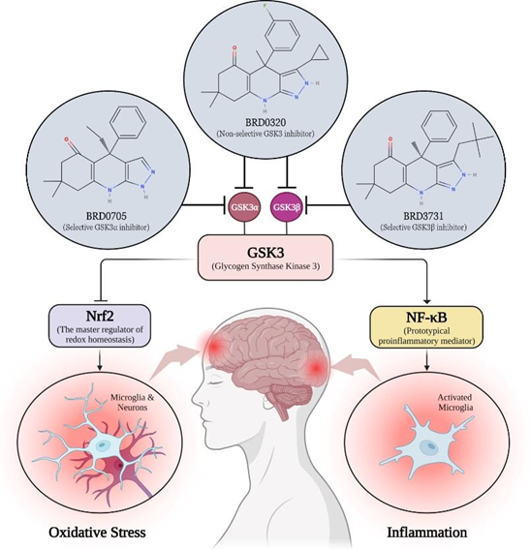
Figure 1. A schematic outlining the GSK3/Nrf2/NF-κB regulatory model underlying GSK3 inhibition in SIM-A9 microglia, as evinced by findings in this study.
Biography

