Investigation of tandoor ovens and tandoor smoke as a public health problem: An epidemiological study in the province of Van, Turkey
Sebahattin Celik¹*, Serpil Sevimli Deniz¹, Hakan Koksal¹ and Osman Abbasoglu²
¹Van Yuzuncu Yil University, Turkey
²Hacettepe University, Turkey
Abstract
Statement of the problem: Indoor air pollution occurs as a result of different circumstances in different parts of the world. The smoke produced by tandoor ovens represents a major source of indoor air pollution in rural areas of the Middle East and South Asia. Although the use of tandoor ovens has serious effects on public health, scientific data on their prevalence, the chemical properties of the biofuels used in them, and the contents of tandoor smoke are almost non-existent.
The purpose of this study: We determined three main objectives for the present study. Our first objective was to determine the number of tandoors in a specific location (prevalence). The second objective was the analysis of the chemical contents of the tandoor smoke with regard to the biofuels used. Our third and final objective was to examine the severity of the burns caused by tandoor ovens [Figure 1].
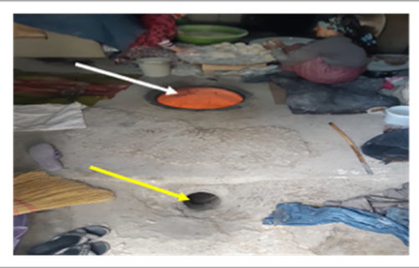
Figure 1. Women preparing dough for baking bread. The white arrow shows the underground tandoor, the yellow arrow indicates the ventilation hole.
Methodology & theoretical orientation: Concerning the first objective, a field study was conducted to determine the number of tandoor ovens existing in a predetermined area (in this case, the province of Van in Turkey). The next step was the chemical analysis of the tandoor smoke from the biofuels, which included dung and wood. Both organic and inorganic molecules were analyzed using internationally accepted and validated methods. Finally, the data collected by the burn unit of a tertiary hospital were analyzed with respect to burn injuries caused by tandoor ovens.
Findings: Almost all of the tandoors (99%) identified in the study were indoor. Dung and wood constituted the main biofuels used in the tandoors. Inorganic components identified in the chemical analysis are presented in [Table 1]. Our analysis found Poly Aromatic Hydrocarbons (PAH), among the most carcinogenic organic compounds, at levels of 0.0049 mg/m³ for the dung + wood tandoor and 0.0005 mg/m³ for the dung-only tandoor. A total of 301 patients with tandoor-related burns (6.7% of all burn injuries) over a period of 10 years were admitted to the burn unit of Van Training and Research Hospital.
Table 1. The results of chemical substance analysis in the tandoor houses.
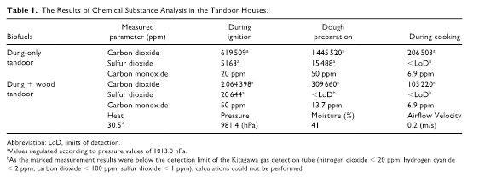
Conclusion: The smoke from dung + wood biofuel is potentially dangerous in terms of inorganic molecules and PAH. Tandoor burns are more common in children and women and are more serious compared with other types of burns.
Biography
Sebahattin completed his medical education at Hacettepe University (Ankara/Turkey). He became a general surgeon at the same institution (2011). He has been providing clinical service as a general surgeon for 11 years. He completed her master's degree in Biostatistics in 2018. He has been especially interested in the epidemiology of diseases for 4 years. He particularly concerned with the environmental problems of women and children, who are disadvantaged groups.

