Performance analysis of carbonization systems and characterization of charcoal produced in the city of Douala
ZAM Jean Freddy
University of Douala, Cameroon
Abstract
In the city of Douala, the production of charcoal with sawing waste is an activity that is gaining momentum and constitutes a real alternative to overcome the phenomenon of degradation of peri-urban ecosystems. However, the performance of the technologies used as well as the characteristics of the charcoals produced remain little studied. This study assesses the performance of the carbonization technologies used and characterizes the charcoal produced. In three major production sites in the city, 45 traditional kilns: 36 earth mounds and 9 earth pits were evaluated. In each carbonization site, the mass yield and economic yield was determined. Charcoals of different species (Tali; Okan; Azobe and Doussie) carbonized in pits and mound were sampled and analyzed to determine their properties. The results obtained show that the properties of charcoals are strongly influenced by the species of wood and the type of kiln. The best yields and charcoal properties were obtained by pit carbonization (25.39 ± 4.88%) and by Azobe wood. These properties vary as follows: moisture contents (6.12% to 3.36%); ash content (0.66% to 2.17%); volatile matter content (16.10 to 24.19%); basal densities (0.49 g.cm⁻¹ to 0.67 g.cm⁻¹); fixed carbon content (67.42% to 78.66%) and higher calorific values of (29.91 to 34.24 MJ.Kg⁻¹). These results lead to the conclusion that the carbonization systems used in Douala have yields similar to those of improved production systems and that the charcoal from sawing waste is of good quality for domestic use [Figure 1].
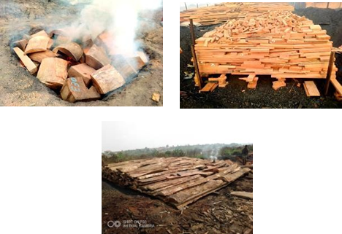
Figure 1. Different forms of sawing waste used for the production of charcoal in the city of Douala.
Biography
ZAM Jean Freddy is a teacher-researcher at the Higher Teacher Training College for Technical Education of the University of Douala, PhD student in engineering sciences at the Laboratory for the Valorization of Forest Resources and Wood (LaReFoB) within the postgraduate school for pure and Applied Sciences of the University of Douala in Cameroon, holder of a Master 2 Research in wood sciences. He has a background as a teacher of high schools and colleges of technical education in science and technology of wood. He is interested in the issues of renewable energy, particularly the energy recovery of woody biomass and the issues of hygroscopic behavior of fuels based on wood material. He is also in charge of teaching some teaching units at the University of Douala: technological and energetic valorization and industrial transformation of wood material.

