Nanometal-based magnesium oxide nanoparticle with C. vulgaris algae biodiesel in diesel engine
Tewodros Derese Gidebo¹* and Arunprasad J²
¹Wolaita Sodo University, Ethiopia
²Anna University, India
Abstract
Many researchers are interested in biofuels because it is environmentally friendly and potentially reduce global warming. Incorporating nanoparticles into biodiesel has increased its performance and emission characteristics. The current study examines the influence of magnesium oxide Nano additions on the performance and emissions of a diesel engine that runs on C. vulgaris algae biodiesel. The trans esterification process produced methyl ester from C. vulgaris algae biodiesel. The morphology of nano additives was studied using scanning electron microscopy, transmission electron microscopy, and energy dispersive X-ray spectroscopy. The fuel sample consisted of biodiesel blends with and without magnesium oxide nanoadditives. The fuel properties of the prepared C. vulgaris methyl ester were found to conform to the ASTM standards. The experimental results were determined by running a single-cylinder four-stroke diesel engine at different load conditions. When compared to B20, a B20 blend containing 100 ppm magnesium oxide nanoparticles enhanced brake thermal efficiency while reducing specific fuel consumption, according to the research. When MgO nanoparticles were introduced to B20, engine emissions of HC, CO, and smoke were decreased [Figure 1].
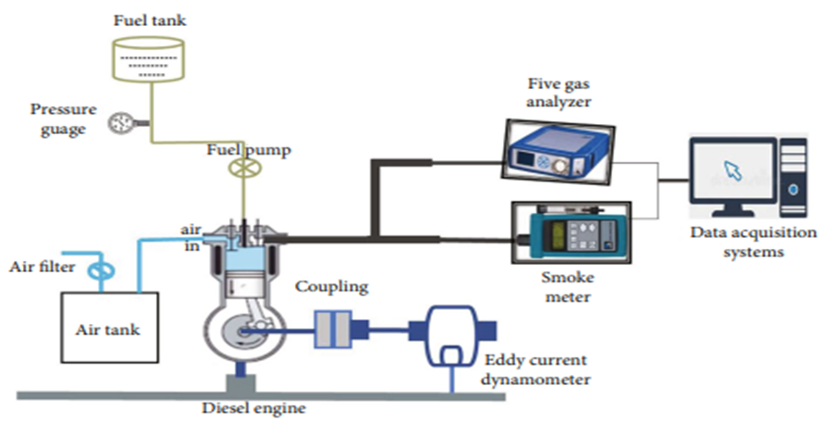
Figure 1. Experimental set-up.
Biography
Tewodros Derese Gidebo is a lecturer of Mechanical Engineering at the University of Wolaita Sodo, Ethiopia. He received his MTech in Aerodynamics and propulsion from Indian Institute of Technology Guwahati, (IIT Guwahati). His research interests is renewable energy especially with biodiesel include the grazing patterns of sheep in western Tibet, and he is currently completing a research in titled Performance Evaluation of Euphorbia Tirucalli L. with Caster Oil Based Biodiesel Fuel.

