A clinico-pathological study of COVID-19 associated rhino-orbital-cerebral mucormycosis
Anbuselvi Thirunavukkarasu
Thanjavur Medical College, India
Abstract
Statement of the problem: Known predisposing factors for mucormycosis are neutropenia and diabetes. Though COVID-19 is associated with hyperinflammatory response, a high surge in Rhino Orbital Cerebral Mucormycosis (ROCM) cases was observed during the second wave. The histopathological features reflect the background pathogenesis.
The purpose is to analyze the histopathological features and clinical presentation of COVID-19 associated ROCM.
Methodology: In this retrospective observational study, the clinical details of 89 proven ROCM patients treated during May–July 2021 were collected from the case records. Histopathological features were correlated with clinical staging groups and outcomes. The mean Neutrophil to Lymphocyte Ratio (NLR) of clinical and outcome groups were compared.
Findings: The mean age was 54.71 ± 11.03 years, with majority of male patients (78.7%). Uncontrolled diabetes mellitus was noted in 70.8% of patients and 3.4% had normal range of blood sugar. The mean blood sugar was 298.08 ± 99.51 mg/dL. The mean duration of onset of symptoms of mucormycosis from the diagnosis of COVID-19 was 17.36 ± 7.392 (3–45) days. Poor outcome with disease progression or death occurred in 21.3% of patients. Clinical group II patients (44.9%) with ROCM stages 3c and above had poor outcomes (P=0.005). Histopathological analysis showed minimal inflammation in 25.8%, Neutrophil Extracellular Trap (NET) in 75.3%, and angio invasion in 28.1% of patients. Minimal inflammation was associated with clinical group II (P=0.004) and poor outcome (P=0.001). Angio invasion correlated with poor outcome (P=0.007). Patients with severe clinical group and poor outcome had higher mean NLR with P=0.017 and P=0.007, respectively.
Conclusion: Vision loss and cerebral involvement had poor outcomes. The histopathologic features such as inflammation and angio invasion along with NLR aid as prognostic indicators in the management of ROCM. The role of NET in the pathogenesis of COVID-19 associated ROCM needs further studies.
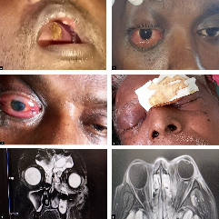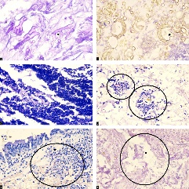
Figure 1.
Biography
Dr. Anbuselvi T has a vast teaching experience in the field of Ophthalmology for both undergraduates and postgraduates. The clinical experience and passion for the effective management of patients in Department of Ophthalmology had led to the successful completion of our study. Experience in the management of COVID-19 patients and the catastrophic presentation of mucormycosis were the driving force for our study. The Department of Pathology played a pivotal role. This study would pave way for holistic management of rhino-orbital cerebral mucormycosis in future.

