Method validation for simultaneous determination of Griseofulvin, two macrolides, and four sulfonamides antibiotics in yogurt samples by SPE clean-up and UHPLC-MS/MS
Sara Kheirandish
Tehran University of Medical Sciences, Iran
Abstract
The transmission of antibiotic residues through the food chain to humans is one of the main concerns of human health due to the emergence of various adverse effects, such as antibiotic resistance. The primary source of antibiotic residues in foods driven from animals is the misuse of antimicrobial drugs in animals. This study aimed to develop and validate a selective and sensitive multi-residues method using ultra-high performance liquid chromatography-tandem mass spectrometry on solid-phase extraction to analyze seven antibiotics from two different antibiotic groups of sulfonamides (sulfadimethoxine, sulfaquinoxaline, sulfadiazine, sulfathiazole) and macrolides (josamycin, roxithromycin), as well as griseofulvin in Iranian yogurt samples. The separation of analytes was applied on the c18 column using reverse-phase and electrospray ionization in a positive mode. The limit of quantification and limit of detection of the method were obtained at 10 ng/g and 3.3 ng/g, respectively, which confirmed the method's sensitivity by the limit of quantification lower than the maximum residue limits. The average recovery was 104.13-116.3%, and the relative standard deviation was ≤16% for all antibiotics. The validated method was applied to 34 actual Iranian low-fat yogurt samples and revealed no antibiotic contamination [Figure 1].
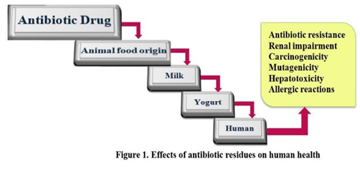
Figure 1. Effects of antibiotic residues on human health.
Biography
Sara Kheirandish is a master of “Toxicology” at Tehran University of Medical Sciences, School of Medicine. She has completed her master thesis on the “method validation for simultaneous determination of antibiotic residues in yogurt samples by SPE clean-up and UHPLC/MS/MS” at Tehran University of Medical Sciences. She also participated as a “research assistant” on the “melatonin and the EAE model of multiple sclerosis” project at Tehran University of Medical Sciences, School of Medicine, and Department of pharmacology. Likewise, she is relatively skilled in method validation, gel electrophoresis, extraction of DNA and RNA, and PCR technique. Furthermore, she is very interested in research in human health, gene expression, food and drug analysis, also bioinformatic topics.

