Artificial intelligence and 6G communication technology
Tareq Bin Ahamed
National Institute of Technology, Bangladesh
Abstract
The next generation 6G communication network would be a six-sense communication network that would add the value of ambient intelligence. With the advancement in every sector of Artificial Intelligence, 6G will fabricate a new utility as “Augmentation of Human Intelligence,” and this utility creation is driving the new generation network. Artificial Intelligence and 6G communication technology will be revolutionized from connecting things to connecting intelligence. In this abstract, we present the bigger picture of the artificial intelligence subdivision that makes a revolt with the help of the 6G Communication Technology. We keep our focus straight to deploying the right application that solves human needs and problems and creates values for new technologies. Machine Learning, Deep Learning, Federated Learning, Big Data, and many more aspects are brought out together to prepare the network for the era of human and machine augmentation. 6G will fully deplorable in an AI ecosystem and use an on-premises cloud that will likely be the outcome for future industrial automation. 6G communication would be rebel in near future with the proper deployment of artificial intelligence. The intelligent network will be fully AI-driven and the cognitive model of the network architecture will effect in every aspect such as artificial general intelligence, artificial narrow intelligence and artificial super intelligence. More importantly the various potential enabling technologies will promise a high Quality of Services (QoS) and a high Quality of Experience (QoE) to transfer the society into an AI- driven smart city. So we can predict that in near future AI and 6G will become more efficient and reliable to the end user. Artificial intelligence and 6G communication network both will be combined together to create a new era in digital communication technology.
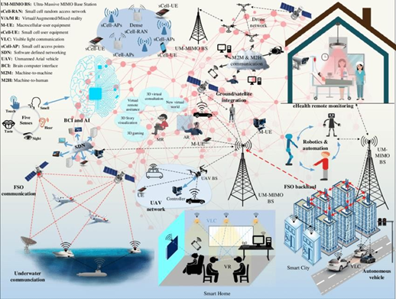
Figure 1. Artificial intelligence use cases with the integration of 6G communication technology.
Biography
Tareq Bin Ahamed, I measure my life by the impact I make. I am a techie and I love making cool products. I believe that data and scale mean power that is why I plunged into the cerebral world of algorithms and the human-machine. I am a Machine Learning Engineer by profession and a researcher interested in the topic of 6G communication technologies.

