Callitetrarhynchus parvus sp. nov. (Cestoda: Trypanorhyncha) a new species from teleost fish Epinephelus aeneus, E. marginatus and Scorpaena porcus from Tunisian waters
Khouloud Bouderbala¹*, Myriam Garbouj¹, Luis Filipe Rangel², Rita D. Cortinhas², Sihem Bahri¹ and Maria João Santos²
¹University of Tunis El Manar, Tunisia
²University of Porto, Portugal
Abstract
Statement of the problem: The genus Callitetrarhynchus Pintner,1931 belonging to the Lacistorhynchidae Guiart, 1937 family is a small genus with only 2 valid species Callitetrarhynchus gracilis (Rudolphi, 1819) Pintner, 1931 and Callitetrarhynchus speciosus (Linton, 1897) Carvajal & Rego, 1985, both infesting a wide range of hosts (Palm, 2004). The aim of the present work is to provide a morphological description, molecular and phylogenetic analysis of a new species Callitetrarhynchus parvus infecting the black scorpionfish Scorpaena porcus Linnaeus, 1758, the white grouper Epinephelus aeneus Geoffroy SaintHilaire, 1817, and the dusky grouper Epinephelus marginatus Lowe, 1834, off Tunisian waters.
Methodology & theoretical orientation: This study combined different approaches such as morphological characterization (SEM and photonic microscopy), molecular (RT-PCR) and phylogenetic analysis.
Findings: The blastocysts of Callitetrarhynchus parvus sp. nov. (Trypanorhyncha: Lacistorhynchidae) were found attached to the external stomach wall of infected fish. Light and scanning electron microscopical observations of larvae showed a scolex with two bothria, a poeciloacanthous atypical, heteromorphous metabasal armature, with 7 hooks, one intercalary hook and one chainette. Hook 7(7’) was unicate with an anterior extension at the base (BR = 3.86-6.38:1). Molecular characterization of the rDNA regions (SSU, LSU and ITS) revealed a high genetic distance between C. parvus sp. nov. and its congeners. The phylogenetic analysis showed that the new species clustered in the Lacistorhynchidae family (Figure 1).
Conclusion: The morphological differences between Callitetrarhynchus parvus sp. nov. and the other Callitetrarhynchus species: C. gracilis and C. speciosus, with the absence of intra-specific variation in the ribosomal DNA sequences of C. parvus sp. nov. larvae from the three studied hosts and the high genetic distance between C. parvus sp. nov. and C. gracilis give a strong support to consider this species as a new member of the genus Callitetrarhynchus.
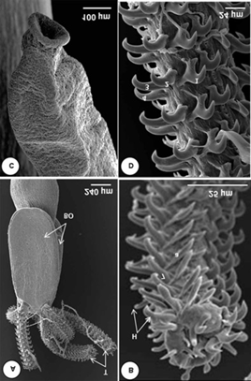
Figure 1: Callitetrarhychus parvus sp. nov. Scanning electron micrographs. A. Scolex with two bothridia (BO), and four tentacles (T). B. External tentacle surface with continuous spiral rows of hooks (H), apical armature. C. Appendix. D. Internal tentacle surface, metabasal armature.
Biography
Khouloud Bouderbala is a PhD student working on fish parasites. Currently she is working on Groupers parasites from Tunisia. She is a specialist in a variety of subjects, including molecular biology, phylogeny, histopathology, and scanning electron microscopy. She completed internships at the University of Porto to strengthen her abilities, particularly in the domains of molecular and phylogenetic biology. As a result of her study, she has published many publications that describe new parasite species and provide ecological approaches to other parasites (Bouderbala et al., 2019, 2020, 2021, 2022).

