Cucumeropsis mannii seed oil annuls dysregulated fertility hormones, kidney function indices, and glucose level in bisphenol A exposed male Wistar Albino rats
Aja PM^{1,3}, Nwibo AC¹, Agu PC^{1,6}*, Ogwoni HA¹, Ekpono E U², Ifie JE³, Ani OG^{1,4}, Awoke JN¹, Ezeh EM⁵, Nwite FE¹, Ukachi OU¹, Nweke PC¹, Ekpono EU¹, Ewa GO¹, Igwenyi IO¹, Alum EU¹, Chukwu DC¹, Nwiziogo FC⁶ and Maduagwuna EK¹
¹Ebonyi State University, Nigeria
²Federal Polytechnic Oko, Anambra State
³Kampala International University, Uganda
⁴University of Chester, United Kingdom
⁵Caritas University, Nigeria
⁶Our Savior Polytechnic Enugu, Enugu State
Abstract
Statement of the problem: BPA (Bisphenol A) is a useful chemical yet possesses myriads of toxicity targeting different levels of organization of life to unleash metabolic syndrome. Plant bioactive possesses limitless therapeutic potential. In this study, we investigated the chemical compositions as well as the tendency of CMSO (Cucumeropsis mannii seed oil) to reverse the dysregulations of fertility hormones, glucose level, and kidney function indices in rats exposed.
Methodology & theoretical orientation: Thirty-six male Wistar rats (180±5 g) were randomly clustered into six groups (A-F) and studied for six weeks following oral administration. Groups: A (Olive oil: 1 ml), B (BPA: 100 mg/kg.bw), C (CMSO: 7.5 ml/kg.bw), D (BPA+7.5 mg/kg.bw), E (BPA+5 ml/kg.bw), and F (BPA+2.5 mg/kg.bw). The chemical constituents and biochemical parameters were determined by standard laboratory procedures.
Findings: Results showed that CMSO contains nutraceuticals in the increasing order of phytoconstituents: phenols>tannins>flavonoids>terpenoids>glycosides>alkaloids>HCN; mineral compositions: Mg>K>Ca>Na>Fe>Zn>P; and vitamins: Tocopherol>retinol>niacin>cobalamin>thiamine>phylloquinone>riboflavin>pyridoxine>calciferol. The in-vivo study showed that BPA significantly (p<0.05) dysregulated the fertility hormone levels [elevated Follicle-Stimulating Hormone (FSH) and reduced Luteinizing Hormones (LH), testosterone, and estradiol], elevated the serum glucose level, and Kidney function indices (urea and creatinine levels). However, the concurrent administration of BPA together with CMSO significantly, reversed the fertility hormones, serum glucose level, and kidney function indices. These phytoconstituents, vitamins, and minerals found in CMSO are nutraceuticals widely reported with several therapeutic effects.
Conclusion: Therefore, we reported that CMSO is a novel nutraceutical intervention annulling several degrees of Bisphenol A-induced toxicity.
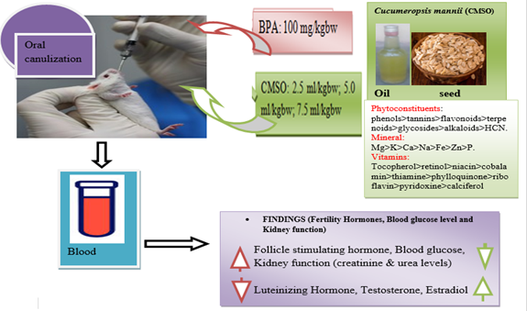
Figure 1.
Biography
Mr. Agu Peter Chinedu is a collaborator of Associate Professor Patrick Maduabuchi Aja’s research colleagues. Mr. Agu studied Science Laboratory Technology as well as biochemistry at Our Savior Polytechnic and Madonna University, Nigeria, respectively, where he had profound academic excellence. He had a master's degree in biochemistry (medical biochemistry) and is currently a PhD scholar at Ebonyi State University Abakaliki, Nigeria. He is a virtual life member of the Bioinformatics Club for Experimenting Scientists (BIOCLUES) Society, India. His area of research interests is reproductive and endocrine toxicity, Cancer chemotherapy, neurodegenerative diseases, molecular biology, nutraceuticals, and natural products. He has bioinformatics skills and currently looking forward to seeing a mainstay in computer-aided drug design, and drug discovery.

