Quaternion algebra on 4D superfluid quantum space-time
Valeriy I. Sbitnev
Kurchatov Institute, Russia
Abstract
Four quaternion matrices of rank 4 η0, ηx, ηy, ηz compose a basis of our 4D space-time. First, we write in this basis the energy-momentum density tensor loaded also by the 4D vector EM potential. Second, we define the generating differential operator D=ic-1∂t∙η0+ ∂x∙ηx+ ∂y∙ηy+∂z∙ηz, where ∂t=∂/∂t, are partial differential operators, c is the speed of light, and i is the imaginary unit. The first step is the application of the differential generating operator D to the energy-momentum density tensor to generate the force density tensor [Figure 1]. This figure shows all steps of applying the differential generating operator D leading to the appearance of gravitomagnetic equations representing the gravito-torsion and the Maxwell EM equations.
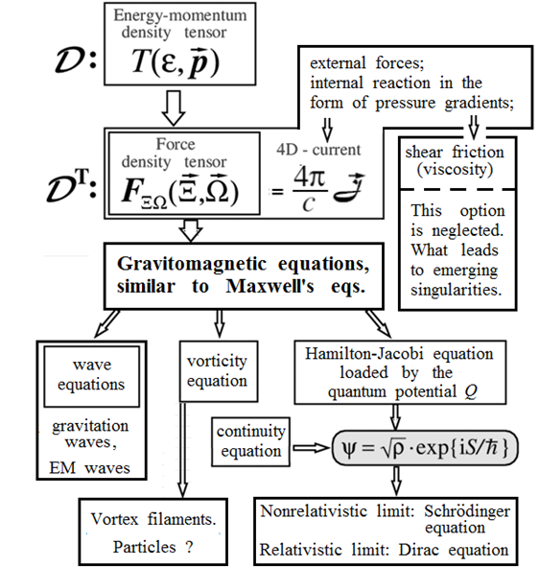
Figure 1. Graphic summary of the report.
Biography
Valeriy Sbitnev has PhD in 1987 from Moscow State University. He is senior researcher in Saint-Petersburg Nuclear Physics Institute, Kurchatov NRC. He has published more than 70 papers in reputed journals.

