Modeling risk and disaster scenarios technologies by explosion of the condensate of natural gas, Alagoinhas/BA
Oliveira Alarcon Matos de* and Nascimento Crislane Santos
State University of Bahia, Brazil
Abstract
Introduction and importance: The transformations in the dynamics of society that occurred after the Industrial Revolution provided significant advances in the global economy, however, environmental impacts and the increase in the number of industrial accidents also intensified. The oil industry was one of the sectors that have grown the most since then, highlighting the increase in the use of natural gas as of the 1970s. The production of this fuel includes its humid part, the gas condensate. In the industrial scope, activities involving this substance can trigger risk scenarios and technological disasters of leakage and explosion of great magnitude, known as Boiling Liquid Expanding Vapor Explosion (BLEVE). Computer modeling and simulation is an important tool for the initial identification of the possible scope of these disasters, helping in emergency training and environmental management.
Case presentation: Thus, this research aimed to simulate the explosion of natural gas condensate stored in a pressure vessel of an industrial plant in the city of Alagoinhas, a city located in the interior of the state of Bahia, Brazil. The study was developed deductively with exploratory research surveying geographic and climatic data and establishing the risk scenarios to be modeled in version 5.4.7 of the software Areal Locations of Hazardous Atmospheres (Aloha). With the results obtained, it was noticed that in all the panoramas analyzed, the explosion radii were greater than one kilometer and that the lethal zone encompasses the pressure vessel location facilities and the surrounding ecosystem.
Conclusion: The objective of the research was achieved, and it was possible to carry out a preliminary consequence analysis for disasters such as the BLEVE with Aloha, despite the limitations of the platform.
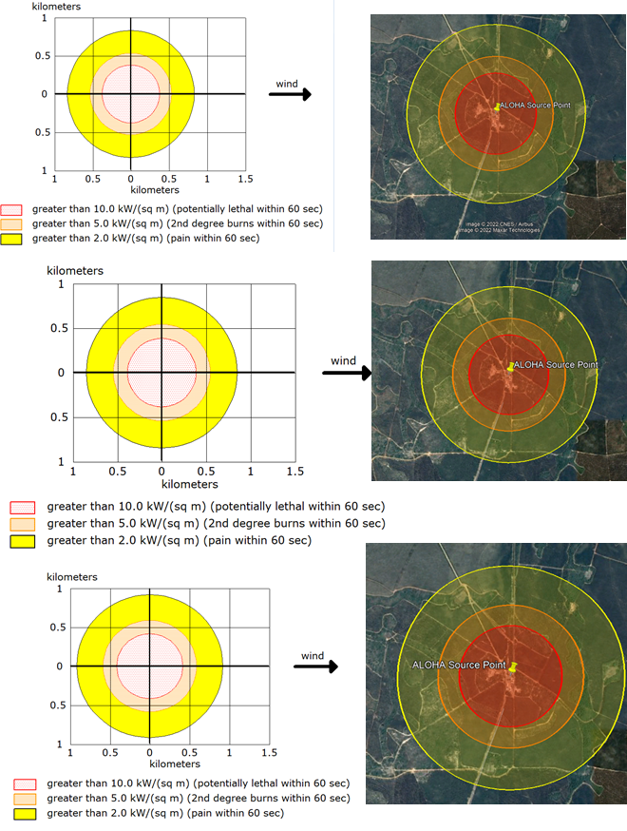
Figure 1.
Biography
Alarcon Matos de Oliveira has a degree in Geography from the State University of Feira de Santana (2008) and a master's degree in Urban Environmental Engineering from the Federal University of Bahia (2012) PhD in Physical Geography from the University of São Paulo (2016). He is a Substitute Professor at the State University of Bahia-UNEB Campos II-Alagoinhas DCET-Department of Exact and Earth Sciences. He is Collaborator/researcher at the State University of Feira de Santana. Has experience in Geosciences, with emphasis on Remote Sensing, acting mainly on the following themes: Geomorphology, Pedology, Climatology, Environmental Modeling, Environmental Risk, Environmental Analysis, Digital Image Processing, Remote Sensing, Cartography, Digital Cartography, Topography, Geographic Information System - GIS, Dam Breaking.

