Computer modeling of TRPC channels gating
Ivan Barvík
Charles University, Czech Republic
Abstract
Statement of the problem: Transient Receptor Potential (TRP)-related channels are a large, diverse superfamily of proteins consisting of six families (TRPV, TRPC, TRPM, TRPA, TRPP, TRPML) and 30 subtypes [1-3]. TRP channels are activated by diverse cellular and environmental signals. Inhibition of TRP channels expressed on nociceptive neurons represents a viable therapeutic pain target. All TRP channels form functional tetramers, with each subunit consisting of six transmembrane segments (S1-S6) flanked by amino- and carboxyl-terminal cytosolic domains. The S1-S4 helices form isolated sensor domains arranged radially around the periphery of the central-ion conducting pore, which is lined with four S5-S6 domains. The central cavity involved in the ion permeation exhibits major constrictions at the selectivity filter, as well as at the lower gate. Unfortunately, not all TRP channels have their closed and open structure resolved [1-3].
Methodology & theoretical orientation: Here, we use bioinformatics tools, sequence and structural alignments, homology modeling, molecular dynamics flexible fitting [4] and non-equilibrium steered molecular dynamics simulations to propose a detail molecular mechanism, and how the TRPC channels are activated.
Findings: We describe pathways through which the signal is transmitted from peripheral sites to the lower gate of TRPC channels. Evolutionary conserved amino acids that serve as key switches during transitions between closed and open states of TRPC channels are identified [Figure 1].
Conclusion: The obtained models of open TRPC channels allow us to perform realistic fully atomic MD simulations including the surrounding membrane, water envelope and ions [5]. These models allow us to investigate effects of agonists and antagonists or different phospholipid membrane composition [6] on the gating of individual TRPC channels.
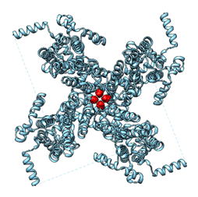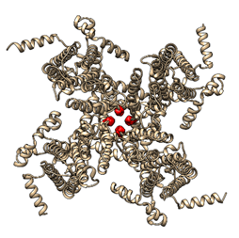
Figure 1. Trans membrane part of the TRPC5 channel in its closed (left) and open (right) state. Amino acid Ile621 from the so-called lower gate is highlighted in red.
References
- Diver MM, King JVL, Julius D, et al. Sensory TRP Channels in Three Dimensions. Annu Rev Biochem. 2022;91:629-49.
- Song K, Wei M, Guo W, et al. Structural basis for human TRPC5 channel inhibition by two distinct inhibitors. eLife. 2021;10:e63429.
- Ruan Z, Haley E, Orozco IJ, et al. Structures of the TRPM5 channel elucidate mechanisms of activation and inhibition. Nat Struct Mol Biol. 2021;28:604-13.
- Trabuco LG, Villa E, Mitra K, et al. Flexible Fitting of Atomic Structures into Electron Microscopy Maps Using Molecular Dynamics. Structure. 2008;16:673-83.
- Marrink SJ, Corradi V, Souza PCT, et al. Computational Modeling of Realistic Cell Membranes. Chem Rev. 2019;119:6184-226.
- Corradi V, Sjdiu BI, Mesa-Galloso H, et al. Emerging Diversity in Lipid-Protein Interactions. Chem Rev. 2019;119:5775-848.
Biography
Ivan Barvík is expert in computer modeling of biomolecules (molecular dynamics simulations, homology modeling, docking, quantum chemical calculations, and rational drug design), high performance computing, parallelization (Open MP, MPI, CUDA), numerical methods. He is author and co-author of 59 papers in impacted international journals (>757 citations, h-index 16). In many of these papers, the so-called TRP channels were studied: Sinica et al. Cells 9 (2020) 57; Zimova et al. Frontiers in Physiology 11 (2020) 189; Zimova et al. Science Signaling 11 (2018) 8621 etc. His research is supported by the Czech Science Foundation (22-13750S).

