Influence of a novel drying technique on the mechanical performance of recycled pet
Alejandra Costantino*, Gabriela Campos, Joaquin Cruces, Federico Morales and Valeria Pettarin
University of Mar del Plata, Argentina
Abstract
Plastic materials are essential in modern societies; they come mainly from fossil resources. That is why recycling is a very important step in the transition towards a circular economy, to avoid continuing to use fossil resources and thus close the cycle of production. PET is currently considered one of the plastics with the greatest potential for being recycled due to its good properties and ability to be processed by industrial processing. However, those processes may deteriorate its properties, such as tensile strength or thermal stability, since they involve high temperatures and shear stresses that together with the presence of moisture (due to the strong hydrophilic nature of PET) can accelerate the thermal oxidation of the polymer with a corresponding loss in molecular weight. When working with recycled PET the excess moisture contained in the material may be higher. Despite the importance that represents the drying stage for this resin, it has not yet been studied how different techniques of drying can influence the final mechanical properties of the processed parts and the cycle total (time/costs). In the present work, two drying techniques were applied, one conventional through an oven widely used in the industry and another novel one through infrared rays (which involved the construction of an infrared oven) to study its influence on the cycle of recycled and mainly in the final mechanical properties of PET parts obtained from of waste soda bottles and virgin material used for comparison. It was found that drying by infrared technology reduces drying time by 80% which implies a drastic reduction in total recycling time for all materials (recycled and virgin). In addition, no significant differences were found in the conventional and non-conventional mechanical properties, which indicate that drying by infrared technology does not degrade or affect negatively the performance of the materials used in the present work.
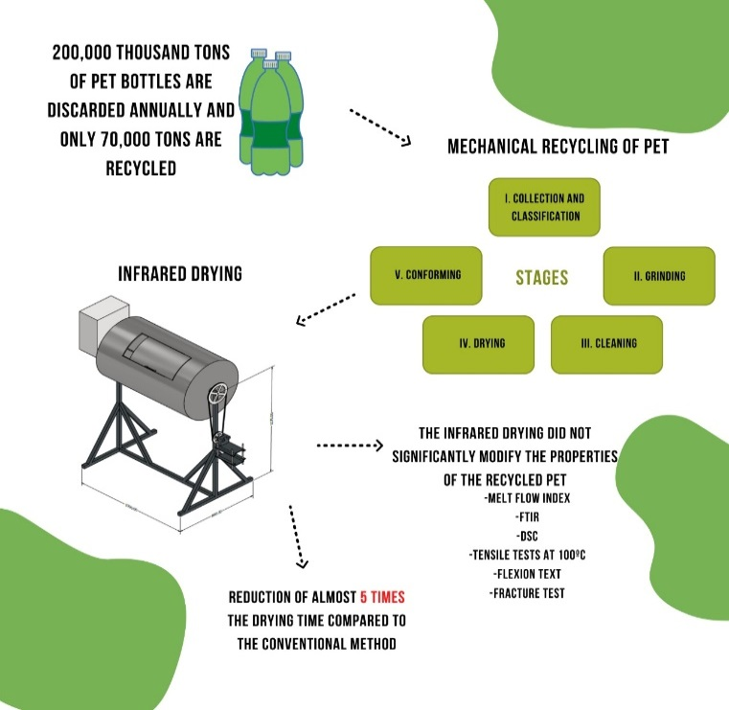
Figure 1.
Biography
Alejandra Costantino; My experience spans the spectrum of virgin and recycled polymers technology from mixing, extrusion, and basic molding processes to nanoscale structure, and numerical modeling. I've worked with multicomponent systems, different processing operations and I've performed mechanical behavior under different stress conditions.

