The prevalence of vitamin D deficiency among pregnant women in mainland China: A meta-analysis and systemic-analysis
Xianrui Chen* and Xiaoxia Lin
The First Affiliated Hospital of Xiamen University, China
Abstract
Background: Vitamin D (Vit D) deficiency during pregnancy is associated with a variety of adverse maternal and newborn outcomes, such as pregnancy loss, gestational diabetes mellitus, preeclampsia, small for gestational age infants, and preterm delivery, etc. However, the large-sample epidemiological data and national surveys of Vit D deficiency among a large group of pregnant women in mainland China are limited. A meta-analysis and systematic review were conducted to identify a reliable estimate of Vit D deficiency during pregnancy prevalence and to reveal its epidemiological characteristics.
Methods: Thorough electronic databases included China National Knowledge Infrastructure, Wanfang, Weipu, PubMed, Cochrane and Embase, relevant studies were searched from inception until August 2021.
Results: Overall, 54 studies were included (n=235,347 cases) in this systemic-analysis, which showed that the pooled prevalence of Vit D deficiency during pregnancy was 60.0% (95% CI:54.1%～66.0%) with high heterogeneity (I2=99.9%, P=0.000). Point prevalence of Vit D deficiency in West China (38.5%) was the lowest, and the prevalence in central region of China (64.1%) was the highest. A random-effects model meta-analysis that was performed to calculate the first, second and third trimester of pregnancy prevalence calculated prevalences of 67.1%, 48.2% and 71.6% respectively. Percentages of Vit D deficiency before 2015 were 63.8%, since then, it has slightly decreased over the past 5 years (54.9%). The prevalence of 30–35 and >35 years old groups were 0.586 and 0.585 respectively. The prevalence was inconsistent due to different measurement methods, the incidence rate of HPLC-MS/MS, CLIA, ECLIA and ELISA groups were 46.2%, 58.7%, 66.6% and 71.5% respectively. Meta-regression indicated that geographic region (P=0.036), age groups (P=0.000), screening year (P=0.026), sample size (P=0.014), method for Vit D measurement (P=0.002), sample source (P=0.000), maternal health status (P=0.002), and literature quality score (P=0.002) may be the factors influencing the prevalence estimates for Vit D deficiency. The overall prevalence of Vit D deficiency in pregnant women using a meta-sensitivity analysis did not change significantly.
Conclusion: Over the past one decade, the prevalence of Vit D deficiency among pregnant women in mainland China has slightly decreased. Maternal Vit D deficiency in economically developed areas still needs to be taken seriously and Vit D deficiency during the third trimester of pregnancy ought to be equally payed special attention. The clinically significant minimum threshold of Vit D levels among pregnant women in mainland China remains to be established and a uniform reference standard should be incorporated into future guidelines.
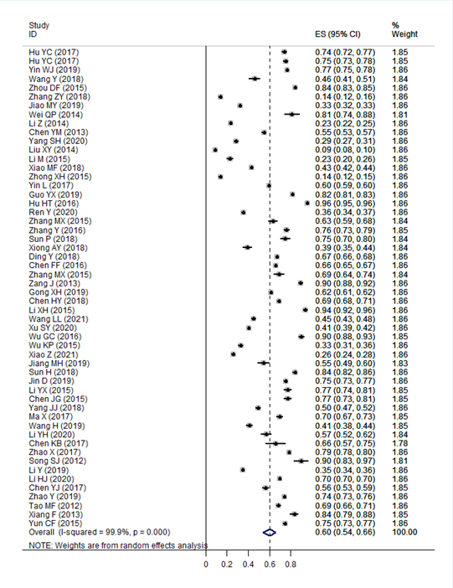
Figure 1.
Biography
Xianrui chen has his expertise in evaluation and passion in improving the postpartum period health of women and Neonatal Health Management. He has years of experience in research, evaluation, teaching and administration both in hospital. He has deep attainment in the direction of child health care, especially in neonatal nutrition and care with rich clinical experience.

