Effect of COVID-19 pandemic on agricultural production and sustainable food system in Fiji
Mohammed Rasheed Igbal
Fiji National University, Fiji Islands
Abstract
The COVID-19 pandemic has caused unforeseen adverse circumstances around the world, affecting the agricultural area, economy, human well-being, and food security. This study analyzed research on Coronavirus according to agricultural creation and food security. Pacific Island Nations (Kiribati, Fiji, Samoa, and numerous others) depend on fisheries and horticultural frameworks for their work and monetary turn of events. However, the situation with the Coronavirus has caused a significant decline in the farming stockpile, economy, and food security framework, leading to neediness, an increase in the unemployment rate, and a reduction in the trip business.
The novel COVID (SARS-CoV-2) infection influenced economies worldwide, excessively affecting people who were defenceless to neediness and craving. Food security has been imperilled both straightforwardly and by implication because the condition destabilized food frameworks and the impacts of lockdowns on family income and actual admittance to food. The COVID-19 pandemic adversely affects every one of the four mainstays of food security, viz. accessibility of food, availability of food, use of food, and security of food. This study concluded that this pandemic immensely affects farming and food supply inside and outside the nation, portraying and showing the significance of agribusiness in each country worldwide. Coronavirus has decreased and negatively affected the development of the food distribution system and business ranchers in Fiji and other Pacific nations. Still, it has also highlighted the central role that horticulture plays in an individual's life since a few families without jobs started cultivating activities to care for their loved ones. The Public Authority proposed and distributed several initiatives, projects, and packages to assist small-scale town ranchers and families improve their food output [Figure 1].
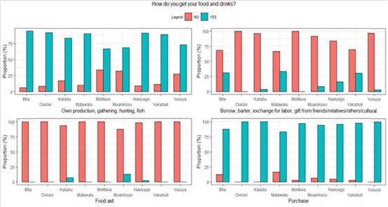
Figure 1. Respondents indicating the type of sources they obtain for food and drinks.
Biography
Mohammed Rasheed Igbal is a final year student undertaking a Master’s in Research (Agriculture, Forestry, Fisheries and Veterinary Science) at the College of Agriculture, Fisheries & Forestry, Fiji National University, Fiji. He has completed Certificate III in Commercial Agriculture, a Trade Diploma in Animal Husbandry, a Bachelor of Science in Animal Husbandry, and Postgraduate Diploma in Agriculture from Fiji National University, Fiji. He has published four papers in international journals, and four papers are accepted in reputed Schimago and Scopus-ranked international journals. In addition, he has attended an oral presentation conference organized by the University of Nottingham, Malaysia. 2nd Conference on Food Systems in Small Islands and the Developing States, 7th to 9th September 2022. His expertise area of Research is Animal Science, Animal diseases, Agricultural food systems, Effects of Climate Change and Impacts of Climate Change on Livestock and Food supply.

