Using MD simulation to study structure and dynamic properties of the 1-n-Alkyl-3-Methylimidazolium tris(perfluoroalkyl)trifluorophosphate ionic liquids
Gholizadeh Atani Kazem
University of Mazandaran, Iran
Abstract
In this study, we applied classical Molecular Dynamics (MD) simulations to understand the structure, dynamics and transport properties of the room-temperature 1-alkyl-3-methylimidazolium family with tris(perfluoroalkyl)trifluorophosphate ionic liquids, abbreviated as [Cnmim][eFAP]. Calculated densities of ionic liquids agree well with experimental data. Local structures were characterized by studying the Center of Mass (COM) and partial site-site RDFs, Combined Distribution Functions (CDFs) and dihedral angles distribution of n-alkyl side chains in the imidazolium cations. The hydrogen bonding between Fluor atoms of anions and hydrogen atoms of imidazolium ring of cations were studied by contour maps of CDFs. Also, dynamical properties of these ILs such as Mean-Square Displacement (MSDs) for center-of-mass of ions, ionic diffusion coefficients and the cationic transference numbers are calculated by simulation in the NVT ensemble. Results show that the length of alkyl-side chain of cation is the major factor to affect these properties. Calculated densities of ionic liquids agree well with experimental data. Calculated densities of four [Cnmim][eFAP] ionic liquids by isotherm–isobar (NPT) ensemble simulations at 298.15 K and 1 atm and shown in [Table 1].
Table 1. Calculated densities of four [C_{n}mim][eFAP] ionic liquids at 298.15 K and 1 atm.
Alkyl chain  length (n) | ρ(gr.cm⁻³)
Alkyl chain  length (n) | This work | Literature | % DEV
2 | 1.721 | 1.709[66] | 0.69
4 | 1.569 | 1.629[66] | 3.82
6 | 1.512 | 1.563[66] | 3.37
8 | 1.602 | NA | -
Radial Distribution Function (RDF) depicts the averaged local structure around a point or atom of interest where it characterizes the local microstructure of a liquid. We calculated the RDFs in this simualtion to better understand of hydrogen bonding in these ILs. Partial site-site RDFs between HR-F, HR-F2C and HR-F3C atoms were calculated and shown in [Figure 1]. It is evident that the F atoms are well organized around HR atoms; however F2C and F3C show smaller and broad peaks at larger distances. This observation can be explained in terms of the more negative charge of F atoms and also the steric hindrance around F2C and F3C atoms. The hydrogen bonding in different H atoms connected to the imidazolium ring was confirmed by many studies both theoretically and experimentally.
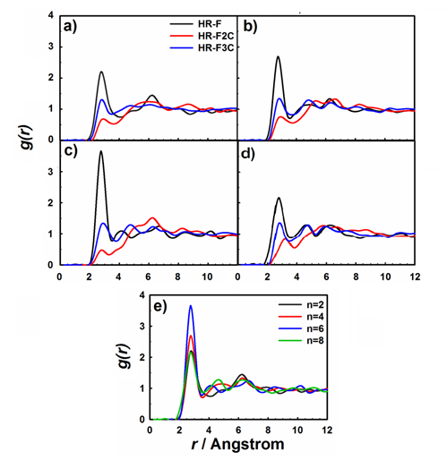
Figure 1. Calculated RDFs for the key atomic sites of the anion–cation (HR-F, HR-F2C and HR-F3C) for [Cnmim][eFAP] where n= a) 2, b) 4, c) 6, d) 8 and e) RDF for F-HR site in four studied ILs at 298.15K and 1atm.
Three types of fluorine atoms of anion can be grouped based on their partial charges and positions F, F2C and F3C. Atom labels are illustrated in [Figure 2].
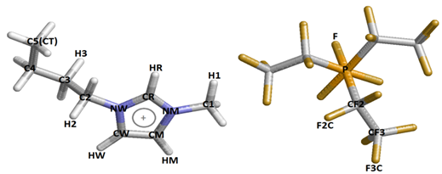
Figure 2. Labels applied to distinguish between the atoms applied in the studied ionic liquids.
The coordination number for the first solvation shell, N, can be calculated by integrating g (r) out to the location of the first minimum,
$$N=4π\int_{0}^{R_{min1}}{ρ_{nd}g(r)r^{2}}dr$$
Where ρnd is the bulk number density and Rmin1 refers to the first minimum in g (r). The coordination numbers for PRDFs in [Figure 1] are calculated and shown in [Table 2]. The coordination number of atom F around HR for all studied ILs is larger than the other fluorine-hydrogen Ns. This is not surprising in terms of the assigned charges to hydrogens of the imidazolium ring, where HR is the most positive among the other ring hydrogen’s.

Table 2. Calculated first maximum and minimum positions of different site-site Radial Distribution Functions and the first shell coordination numbers (N) at 298.15 K and 1 atm.
[C_{n}mim][eFAP] | type | First r_{max} position (Å) | First g (r_{max}) value | First r_{min} position | First g (r_{min}) value | Coordination number (N)
n=2 | F-HR | 2.65 | 3.082 | 4.45 | 0.518 | 0.665
n=2 | F-HM | 2.85 | 1.964 | 3.75 | 0.567 | 0.342
n=2 | F-HW | 2.85 | 1.964 | 3.45 | 0.192 | 0.224
n=2 | F2C-HR | 3.05 | 1.102 | 3.35 | 0.254 | 0.110
n=2 | F3C-HR | 2.65 | 1.568 | 3.25 | 0.647 | 0.179
n=4 | F-HR | 2.65 | 3.728 | 3.55 | 0.416 | 0.360
n=4 | F-HM | 2.65 | 2.051 | 3.75 | 0.466 | 0.326
n=4 | F-HW | 2.55 | 2.617 | 3.25 | 0.372 | 0.199
n=4 | F2C-HR | 3.15 | 0.989 | 3.35 | 0.350 | 0.115
n=4 | F3C-HR | 2.75 | 1.789 | 3.65 | 0.590 | 0.248
n=6 | F-HR | 2.55 | 4.402 | 3.35 | 0.638 | 0.370
n=6 | F-HM | 2.55 | 2.201 | 3.05 | 0.462 | 0.137
n=6 | F-HW | 2.65 | 2.650 | 3.55 | 0.568 | 0.231
n=6 | F2C-HR | 2.85 | 0.617 | 3.25 | 0.136 | 0.057
n=6 | F3C-HR | 2.95 | 1.700 | 3.95 | 0.489 | 0.304
n=8 | F-HR | 2.65 | 4.010 | 3.95 | 0.361 | 0.426
n=8 | F-HM | 2.65 | 2.606 | 3.65 | 0.528 | 0.249
n=8 | F-HW | 2.65 | 3.007 | 3.95 | 0.271 | 0.350
n=8 | F2C-HR | 3.15 | 0.993 | 3.55 | 0.447 | 0.128
n=8 | F3C-HR | 2.65 | 1.671 | 3.25 | 0.444 | 0.156
Biography
I have graduated with PhD degree from university of Mazandaran and currently teach the chemistry in Tehran’ high schools and institutes. I already have professional and academic experience in the molecular dynamics simulation field of bulk and confined ionic liquids and their gas uptake. I worked on the structural and dynamic properties of mentioned systems. I have sufficient proficiency in many general and professional simulation softwares such as LAMMPS, DL_POLY and GAUSSIAN as well as different software and program to analyze the simulation results such as origin. Areas of expertise include MD simulation of bulk ILs, confined ILs in different nanotubes, gas uptake by bulk and confined ILs, Grand Canonical Monte Carlo (GCMC) simulations and quantum simulation by GAUSSIAN. In the MSc. and PhD courses, with cooperation of our team and my professors, I have published 2 articles in the peer-reviewed journals and at present, we are ready to prepare the new article about the structural and dynamic properties of confined ILs. Also, I have a most motivation and interesting to study the mentioned systems, drug-polymer interaction and various models by quantum simulations.

