Active Post-marketing Drug Surveillance for Several Adverse Events: Saudi Food & Drug Authority Experience
Eman Alghamdi, MPharm(Hons),Saudi Food and Drug Authority.

Abstract (300 word limit)
Post-marketing drug surveillance for adverse drug events (ADEs) has typically relied on passive spontaneous reporting. Recently, SFDA have turned their attention to more preemptive approaches that use existing data for active surveillance. Thus, A post-marketing surveillance program was implemented to evaluate the safety of Monoclonal Antibodies Diseases Modifying Agents (MABs). The objective of this presentation is to evaluate the safety of (Ocrelizumab, Natalizumab, Rituximab, and Alemtuzumab) in multiple sclerosis patients. Methodology & Theoretical Orientation: A retrospective cohort study using real-world data from a tertiary hospital in Riyadh, Saudi Arabia was performed to detect safety profile of MAB in patients with MS. The Study included treated patients with one of the MABs from January 2015 to December 2021. The objectives were to identify Adverse Drug Event (ADEs) associated with the use of MABs. The medical dictionary for drug regulatory affairs (MedDRA) was used to classify ADEs according to the System Organ Classification (SOC) and the Preferred Term (PT). ADEs were classified based on the seriousness, and expectedness, according to SFDA guidelines on Good pharmacovigilance Practices. Descriptive analyses were performed, including frequency/percentages for categorical variables and mean or median for continuous variables. All ADEs were crosschecked listing with local summary product characteristics (SPC), United States Food and Drug Administration (FDA) drug label, and European SPC to identify new safety signals using the scheme illustrated in Figure 1.
Findings: 214 patient’s records met the eligibility criteria, ocrelizumab (144), natalizumab (46), rituximab (19), and alemtuzumab (4). Their socio-demographic characteristics are summarized in Table 1.
Table 1: Demographic characteristics of the study population (n=214)
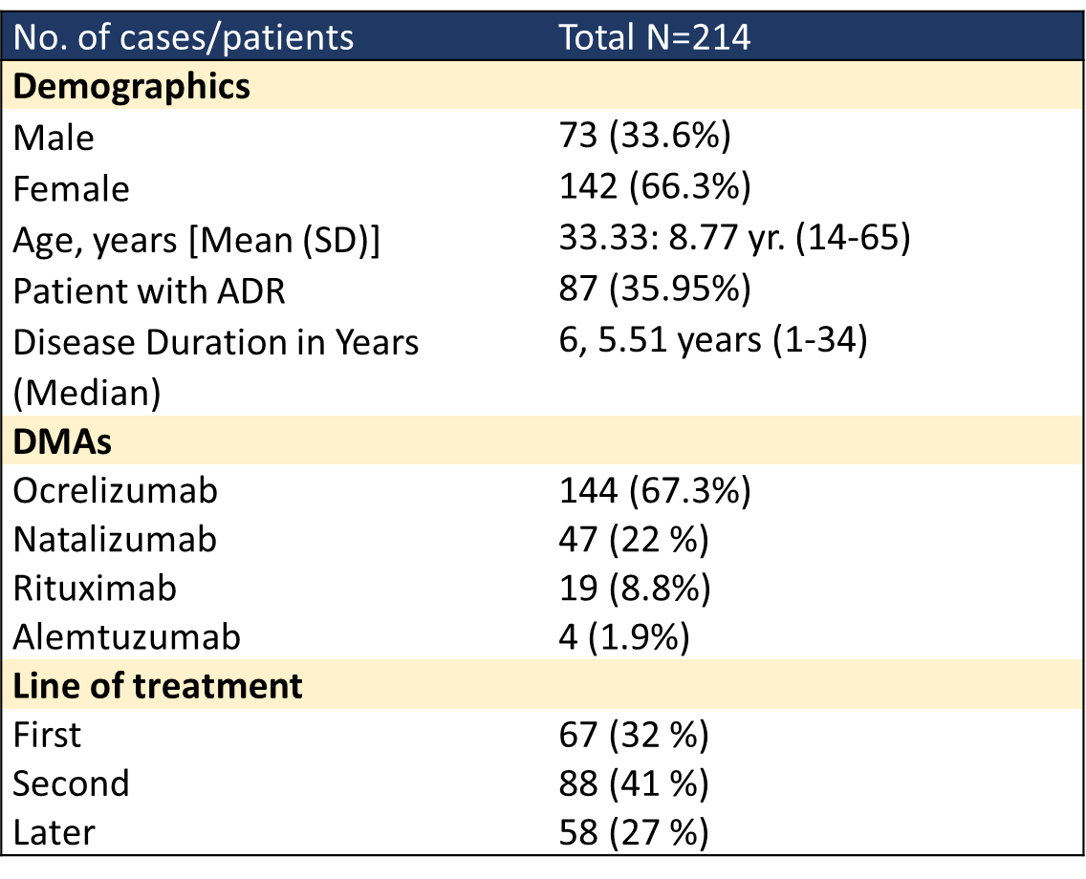
A total of 133 ADEs were reported with the use of MABs including 55 serious ADEs. Based on the local and international product information assessment, there were 42 unexpected ADE (potential signals), 79 known and labeled ADEs, and 13 ADEs not labeled in the local product information label but included in the product information label approved by the FDA or European Medicines Agency. Fig 1

Figure: Description of adverse drug events associated with the use of monoclonal antibodies in MS patients (total ADE: 133)
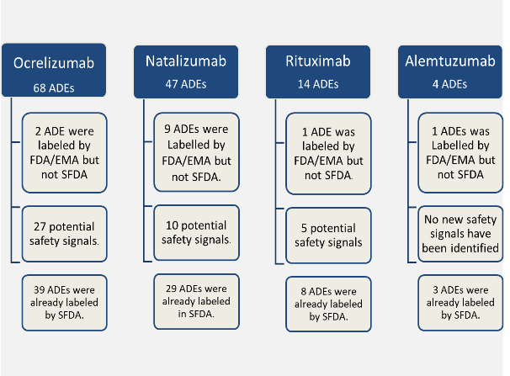
Nil
Signal validation
Label update

Conclusion:
This study shows an acceptable safety profile of MABs in MS patients. Besides, it reports data that identified new safety signals not previously addressed in the local & international product information label, which need further investigation. Thus, there are strong motives for implementing similar programs to provide data for updated risk–benefit analyses.

Recent Publications (minimum 5)
1. Browne P, Chandraratna D, Angood C, Tremlett H, Baker C, Taylor BV, et al. Atlas of multiple sclerosis 2013: a growing global problem with widespread inequity. Neurology. 2014;83:1022–1024.
2. AlJumah M, Bunyan R, Al Otaibi H, Al Towaijri G, Karim A, Al Malik Y, et al. Rising prevalence of multiple sclerosis in Saudi Arabia, a descriptive study. BMC neurology. 2020;20:49.


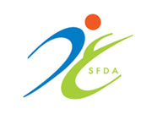
Biography (150 word limit)
Eman Alghamdi has her expertise in drug safety started from 2015, at hospital setting since she worked as Drug and Poison Information Pharmacist, she was in-charge for the adverse drug reactions, overdosing, and toxicity cases. In 2017-2018, she was member in Quality Improvement and Patient Safety Joint Commission International team. Then, in 2019, she has joined SFDA, in the Pharmacovigilance Executive Directorate, as Senior Drug Safety Specialist. My main task is evaluating the safety of medicinal products available in Saudi Arabia proactively and whenever there is a potential safety signal. I was honored to be a secretary of the National Higher Advisory Pharmacovigilance Committee. Ms Alghamdi is a member of many scientific and national committees and has participated in several local and international conferences related to drug safety as moderator, speaker, she the country representative in the ISOP Middle East Chapter.
Email: drXXXXXXX@xxxmail.com

Notes/Comments:

Presenting author details
Full name: Eman A. Alghamdi
Contact number: +966554422800
Mail id: e.aghamdi@sfda.gov.sa
Category: (Oral presentation)

