The association between visual impairment and cognitive decline
Fatima Khalifa Mohamed Ahmed
Comenius University, Slovakia
Abstract
It has not yet been fully established that visual impairment is associated with cognitive decline in the elderly. As it is unclear whether the association is causal or direct, many cross-sectional studies have found a correlation between these two comorbidities, but some longitudinal studies have failed to find a direct relationship. Most of these studies were conducted in western and Asian countries. The hypothesis is that visual impairment or worsening decreases the stimulation of cognitive function, resulting in a decline in cognition and dementia.
Establishing a clear understanding of the relationship between cognitive decline and impairment of vision may aid in developing strategies for early detection and management of risk factors, thereby reducing clinical and public burden while improving quality of life. In addition to the increased risk of physical injuries, social withdrawal, and depression associated with visual impairment, there is also a great risk of chronic comorbidities as a result of the physical inactivity. As the risk of developing cataract, age-related macular degeneration, and glaucoma increases with age, it is more common to see visual impairment and blindness in elderly people.
In those studies snellen chart was used to assess the visual acuity, for assessing mental status or cognitive function different scales were used in different studies, as an example; the validated Short Portable Mental Status Questionnaire was used in the Singapore as well as in Taiwan studies, whereas the Mini-Mental State Examination (MMSE) was done in the Maryland, US study, other confounding variables are; age 65 years and older, sex, marital status, educational and social levels, BMI, presence of diabetes mellitus, hypertension and hyperlipidemia.
The presence of visual impairment in elderly populations could adversely affect cognitive functioning in the future. Preserving good vision may be an important interventional plan for reducing age-related cognitive decline [Figure 1].
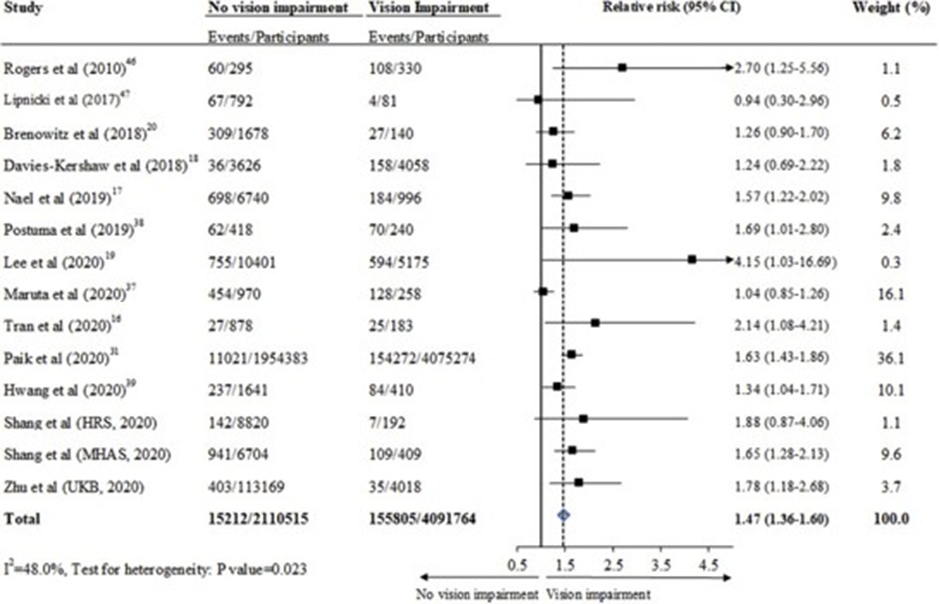
Figure 1. Forest plot showing the relative risk of incident dementia in participants with and without vision impairment in prospective cohort studies. Central squares of each horizontal line represent the relative risk for each study. Horizontal lines indicate the range of the 95% confidence interval (CI), the vertical solid line indicates the relative risk of 1.0, and the vertical dash line indicates the pooled relative risk of included prospective cohort studies.
Biography
Fatima Khalifa Ahmed was born and raised in Rabat, Morocco to Libyan parents. She has Bachelor degree in medicine in Comenius University in Bratislava, Slovakia, Postgraduate internship year in Cairo university hospitals in Egypt, Completed a course in leading healthcare quality and safety offered by The George Washington University, as she is interested in taking actions into improving the quality and safety of healthcare systems Pursuing ophthalmology as a career of choice as it combines her passion in science and research with the clinical and surgical division of medicine Passionate about discovering different cultures and learning new languages (Currently learning Italian) Arabic, English German and Slovak are among the language spoken.

