An innovative strategy for students’ engagement in nursing education: Smartphone use in active teaching & learning
Juliana Agubokwu
Bowie State University, USA
Abstract
Introduction: The rigor in nursing education makes it imperative for nursing faculty to continuously innovate strategies to engage the students. However, attrition continues in nursing education despite the use of traditional strategies, active learning strategies, and technologies in a didactic face-to-face learning environment.
Study goal: To explore the perceptions of undergraduate nursing students regarding the combined use of active learning strategies and technology, precisely, smart phones in a didactic face–to-face teaching/learning environment. The study also explored effective ways of using smart phones in a didactic face-to-face learning environment to improve academic engagement and reduce the level of attrition in nursing education.
Methods: A qualitative study of undergraduate nursing students at different levels, using semi-structure interview and manual data analysis, using the following framework analysis steps; familiarization, identifying a thematic framework, indexing, charting and synthesis, mapping, and interpretation.
Findings: After conducting the data analysis, it significantly resulted in six themes and 13 subthemes as follows [Figure 1]:
- Benefits of smartphones with two sub-themes
- Channel for constant communication, active learning and engagement with three subthemes
- Active learning methods & Attrition with two subthemes
- Faculty effort with three subthemes
- Participants’ suggestions with two subthemes
- Limitations and Challenges with one subtheme
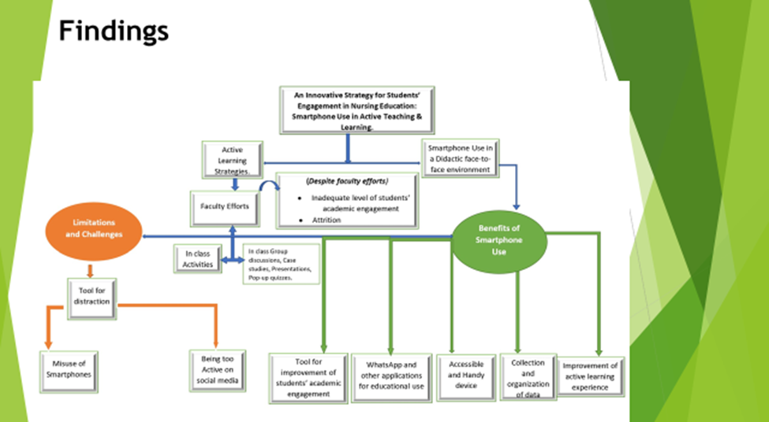
Figure 1. Findings.
Conclusion: The combined use of active learning strategies and smart phone in an undergraduate nursing course will improve academic engagement and promote the desired outcome of academic success, reduce the level of attrition and improve the rate of passing nursing board examination, the NCLEX-RN.
Biography
Juliana Agubokwu is an Assistant Professor and lead faculty of Community Health Nursing at Bowie State University, Maryland USA. She has over 2 decades experience as a Registered nurse in various nursing specialties. Her research interests include innovative teaching strategies for student’s engagement, retention and mentorship. She has conducted research on Hepatitis B and C. She has wealth of experience and great passion for care of people in the community especially the vulnerable population. She has received several awards including a Presidential Volunteer Service Award.

