Platelet-rich fibrin membrane pterygium surgery
Ahmad Kunbaz*, Omer Faruk Yılmaz and Halit Oguz
Istanbul Medeniyet University, Turkey
Abstract
Objective: This oral presentation aims to present a case of platelet-rich fibrin membrane pterygium surgery.
Introduction: Pterygium is a common disorder worldwide. It’s due to the abnormal growth of fibrovascular tissue of the degenerative bulbar conjunctiva over the limbus onto the cornea. The most common risk factor is long-term exposure to Ultraviolet (UV) radiation, especially from the sun.
Nowadays, there have been many different surgical techniques for pterygium excision, starting from leaving bare sclera, which is rarely used in advanced medicine. The current most used technique is the conjunctival autografts, but recurrence risk is remaining a major concern. However, no surgical technique is accepted as the gold standard treatment that prevents recurrence. Platelet-Rich Fibrin (PRF) was first described by Dohan et al. in 2006, which contains cytokines, platelet-derived growth factors, and many growth factors that facilitate regeneration.
Methods: A special technique was applied for the preparation of the fibrin membrane. Blood samples were taken from the patient's antecubital vein with a 24-gauge needle into two tubes that did not contain anticoagulants. Blood samples were immediately centrifuged at 3,000 rpm for 10 minutes using a table centrifuge system. After centrifugation, 3 layers are formed: cell-free plasma at the top, platelet-rich fibrin clot in the middle, and red erythrocytes at the bottom (Figure 1). Before surgery, the contents of the tube are poured onto sterile gauze (Figure 2). The fibrin layer is formed into a thin layer by pressing lightly between sponges. As soon as the PRF membrane was prepared, it was sutured, without any delay. The sclera is closed by suturing the conjunctiva and the fibrin membrane continuously with 10/0 nylon.
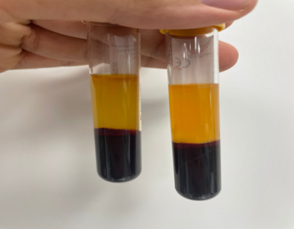
Figure 1. The appearance of 3 layers in the tube without anticoagulant after centrifugation.
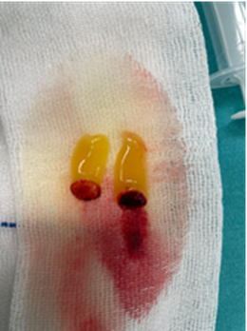
Figure 2. The view of Platelet-rich thrombocyte membrane on gauze.
Case presentation: 74 old female patient presented to our clinic with symptomatic pterygium in both eyes (Figure 3). She was operated on with the Platelet-Rich Fibrin (PRF) membrane technique for pterygium surgery.
It was observed that the fibrin membrane thinned and its color faded in the first week after surgery.
In the 3rd week, it was observed that the platelet fibrin membrane was not completely dissolved. continuous sutures were removed at 3 weeks. at two-month follow-ups, the patient did not have any complications and no recurrence was detected.
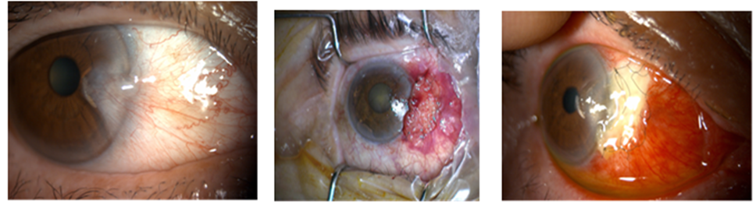
Figure 3. Photograph of the patient who underwent platelet fibrin membrane excision before surgery, during surgery, and in the 3rd week after surgery.
Conclusion: Pterygium surgery with platelet-rich fibrin membrane is performed in a shorter time compared to autograft surgery. Especially in patients with glaucoma, the conjunctiva is preserved for future surgeries. Large case series and long follow-up periods are needed in terms of recurrence and late complications.
Biography
Ahmad Kunbaz has completed his M.D. degree at Cerrahpasa faculty of medicine, Istanbul university. He has published more than 20 scientific papers with more than 200 citations and is currently enrolled in the faculty of medicine, Istanbul Medeniyet University, department of ophthalmology as an ophthalmology resident.

