Retention evaluation of CAD/CAM crowns and titanium base abutments after surface treatments: An in vitro study
Seba Alhebsh
King Abdulaziz University, Saudi Arabia
Abstract
Statement of the problem: The use of Titanium Base (Ti-Base) is increasing and has become a favored alternative as part of abutments for implant-supported FDPs in the digital workflow. Its main disadvantage is de-bonding. This study aims to test one of the newest materials in the market Poly-Ether-Ether-Ketone (PEEK) a material that has been approved by FDA in 1988 for oral application in dentistry, after adding surface treatment to the Ti-Base abutment to study the influence it implies on crown retention. After literature review, and up to this date, no study has evaluated the retention of PEEK crowns to Titanium base abutments after surface treatments. PEEK is widely used in many fields such as in the fabrication of aerospace, automobiles and in spinal reconstruction in surgery. The purpose of the present study is to evaluate the retentive forces of CAD/CAM fabricated (PEEK) crowns cemented on titanium base abutments treated with three different surface treatments.
Methodology & theoretical orientation: Four groups and created in the study, the first group is the baseline, having no surface treatment the second group has aluminum oxide surface treatment, the third group is acid etched using 35% HNO₃-5% HF, and the fourth group has a combination of two surface treatments which are the acid etch and the aluminum oxide. All groups will include a Ti-Base abutment and a prefabricated PEEK crown cemented using RelyX U100, all samples will undergo tensile pull-out testing using Autograph AGS-X Series universal testing machine to test the retention [Figure 1].
Conclusion: The fourth group exhibited statistical significance after testing its tensile force to confirm the retention between Ti-Base abutment and PEEK crown. Recommendations are made to study more material other than PEEK with the same Ti-Base abutment to resolve the de-bonding problem.
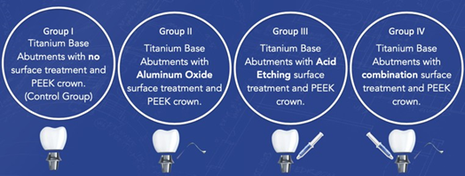
Figure 1. Showcases the study group that has been divided in this study and their different surface treatment modalities.
Biography
Seba Alhebshi has her expertise in maxillofacial prosthodontics and inventing. Her creative and diverse method of solving issues created a constructive pathway for improving healthcare. She has built this model after years of experience in research, evaluation, invention, and academics both in the dental office and education institutions. The internet that the author found in this research is that it utilizes the most up-to-date material, Poly-ether-ether-ketone, combining it with the pioneering Titanium-Base abutment, almost creating a new gold standard for fixed dental prosthesis replacement on dental implants.

