Comprehensive dental treatment for a patient with hemophilia a under general anesthesia
Saleh Sonbol
King Saud University, Saudi Arabia
Abstract
Introduction: Hemophilia A is a genetic coagulation disorder associated with a deficiency of clotting factor VIII (FVIII). It can be inherited or acquired and have different levels of severity. The degree of severity is varied: severe (<1 IU/dl of factor VIII), moderate (1-5 IU/dl), mild (6-40 IU/dl). The clinical characteristics of all types of hemophilia are similar: spontaneous or traumatic hemorrhages; muscle hematomas; hemophilic arthropathy caused by recurrent bleeding into target joints; and bleeding into the CNS. Without suitable exogenous clotting factor replacement therapy these manifestations of the disease could result in disabling or even deadly sequelae, which negatively impact patients’ quality of life and reduce their life expectancy.
This case describes the management of 6 years old boy with mild hemophilia A, who underwent full mouth dental rehabilitation under general anesthesia.
Case report: A 6-year-old Saudi male with mild type hemophilia A, who presented to the pediatric dental clinic with pain pointed to lower left area, lower left primary second molar was with large occlusal buccal restoration, recurrent caries and buccal intraoral abscess. The patient has multiple carious teeth needs comprehensive dental treatment. Due to his uncooperative behavior the patient referred for full mouth dental rehabilitation under general anesthesia.
Treatment course: Based on the consultation received from the hematologist the patient needs factor VIII prior to general anesthesia.
The patient was admitted on 4th of November 2021. A blood test was performed to assess the severity of the hemophilia by evaluating the FVIII level. A Complete Blood Count (CBC) with a differential count of the white blood cells was also performed. The blood test results showed a low FVIII concentration in plasma (14 IU/dl); the hemoglobin level (13.3 g/dl) and platelet count (280000/uL) were within the reference ranges. In addition, the results of blood tests revealed a normal prothrombin time (PT: 14s) (reference range: 11.5–14.5 s), and prolonged activated partial thromboplastin time (APTT: 51.3s) (reference range: 25–40s). The results showed he had a mild hemophilia A, These findings were consistent with the medical history of the patient [Figure 1].
Full dental rehabilitation planned on 5th of September 2021. The patient was administered FVIII 500IU intravenously 2 hours prior to general anesthesia. The treatment has been performed listed in [Table 1].
Table 1. Full dental rehabilitation treatment.
Tooth | Treatment | Tooth | Treatment
#55 | Pulpotomy+SSC | #75 | Extraction
#54 | Class I composite | #74 | Pulpotomy+SSC
#64 | PRR | #84 | Extraction
#65 | Pulpotomy+SSC | #85 | Pulpotomy+SSC
Impression for Band&loop has been taken on #85 to be cemented during 1 week follow-up
The patient was discharged from the hospital on 5th of September 2021. He continued with the follow-up as an outpatient.
After one week the patient attended for 1 week follow-up with no complaint and all restorations and Crowns were intact Band & loop were cemented on #85 [Figure 2].
6 month after the patient attended for 6 month recall with no complaint with good OH and all restorations & Crowns were intact, Pit and fissure sealant were done on #16 #26 #36, One week after reverse band & loop were Cemented on #74 [Figure 3].
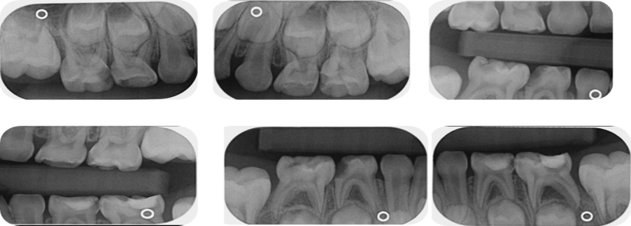
Figure 1. Pre-treatment radiographs.
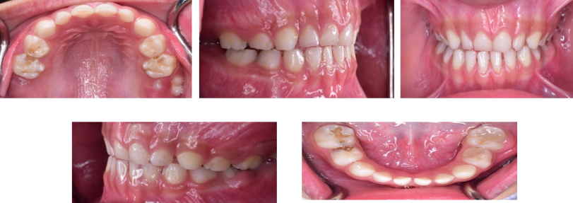
Figure 2. Pre-operative photographs.
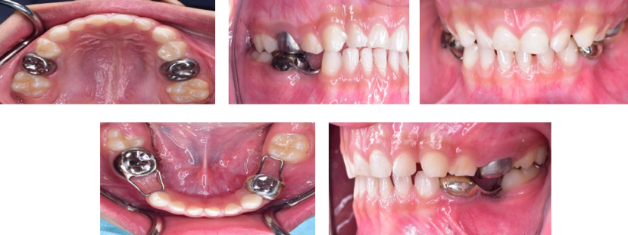
Figure 3. Post-treatment photographs.
Biography
Saleh Sonbol is currently Saudi board Pediatric dental resident at King Saud university, He have been nominated in The Dean's Honor List in his University, he won First place award in poster display during 1st Dental Student Research Meeting held at King Saud Dental University Hospital.

