Evaluation of the upper arch morphological changes after two different protocols of expansion in early mixed dentition: Rapid maxillary expansion and invisalign® first system
Chiara Pavoni¹* and Paola Cozza²
¹University of Rome Tor Vergata, Italy
²UniCamillus-Saint Camillus International University of Health Sciences, Italy
Abstract
Objective: To compare the effects of two different expansion protocols in terms of 2D linear, angular measurements, and 3D analysis of palatal area on digital casts in a group of patients in mixed dentition.
Materials and methods: Digital casts of 31 children treated with the RME (RG:17 subjects), or with the First System (FG:15 subjects) were collected. Linear and angular transversal values were measured in both groups on the upper arch for each T1 and T2 models. In order to measure palatal area, a gingival and a distal plane were used as boundaries for the palate. Unpaired t-test was used to test significant differences between groups.
Results: The comparison of T2-T1 changes for linear measurements between groups showed significant differences in the inter-canine width (+1.5 in FG), in the first inter-deciduous molar width (+1.5 in FG), in the first inter-molar distal width (-1.2 in FG), in the inter-canine transpalatal width (+1.5 in FG) and in the first inter-deciduous molar transpalatal width (+1.4 in FG) [Figure 1]. The analysis of angular measurements showed a significant increase of the crown angulation for all the teeth in FG except for the first molars, which showed a reduction of this parameter [Figure 2]. FG patients showed a greater increase of the palatal area [Figure 3].
Conclusion: First System proved to be efficient in the expansion of the maxillary arch with a better control of the upper first molars crown angulation when compared with the RME and with a greater increase of the palatal area.
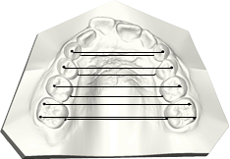
Figure 1. Upper maxillary arch linear measurements.
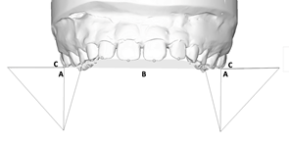
Figure 2. Crown angular measurements.
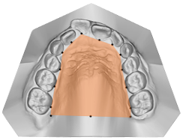
Figure 3. Definition of the palatal area (orange) of the maxilla.
Biography
I have a broad background in Orthodontics and biomechanical teeth movements, with specific training and expertise in cranio-facial growth and orthopedic treatment in growing patients. My research includes the behavior of the growth factors, the directionality of the growing facial structures and undergoing orthodontic treatment, the cellular and structural potential of response to orthodontic treatment in growing patients, the new approaches of maxillofacial surgery with three-dimensional visualization, modern conceptions the tooth movement in three-dimensional software, new protocols and new approaches to orthodontic treatment for the resolution of the most complex malocclusions. I laid the groundwork for the proposed research by developing my personal ability to handle well three-dimensional visualization software (as used by AlignTechnology) and having excellent knowledge of biomechanical orthodontic. This knowledge, which come from many years of clinical orthodontics with MBT technique, they are integrated with the latest knowledge of pure mechanical engineering and 3D design.

