Challenges in computer guided mandibular resection and reconstruction
Ahmed A. Barakat
Cairo University, Egypt
Abstract
One of the main advantages of computer guided mandibular resection and reconstruction is keeping the normal alignment of the bony segments and preserving their harmony and orientation to maintain normal function and esthetics. In some situations, the normal orientation and contour is disturbed and so we need to restore it back. The adjustment of the bony segments was performed using the 2D dicom images and the 3D volumes, and the achieved results were transferred to the actual surgery using specially designed splints and Patient Specific Implants (PSI). The combined 2D-3D planning and the accuracy of the generated splints and PSI proved to be a technique that showed excellent outcomes [Figure 1].
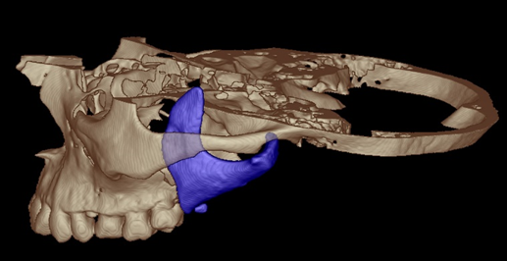
Figure 1. Showing the only remaining piece of the mandible (in blue).
Biography
Restoration of the facial contour and esthetics was my passion in Oral and Maxillofacial Surgery; I was quite concerned about that in orthognathic and tumor surgery. I started using computer assisted procedures in dental implantology, and then I expanded to maxillofacial surgery and was fascinated with the potential and the results. I started to learn 3D modelling and planned my cases myself and designing my splints, prosthetic joints, and custom patient specific implants. I believe this is the best treatment I can give to my patients and encourage all the fellow practitioners to enter the field of modelling to add more and more innovative and creative ideas.

